

**Informatics Institute of Technology**

Department of Computing

(B.Eng.) in Software Engineering

Module Name: Web Design and Development

Module No: 4COSC011C

Group Coursework Report

UoW ID :W1761212

IIT ID : 2019181

Student First Name : Nimna

Student Surname : Fernando

Coursework Group :A-10

Content **Error! Bookmark not defined.**

1. Introduction 3

2. Technical Discussion 4

• Presentation Page **Error! Bookmark not defined.**

• Main Page **Error! Bookmark not defined.**

• Font size change **Error! Bookmark not defined.**

• Comments Form **Error! Bookmark not defined.**

• Buy products **Error! Bookmark not defined.**

• Quiz **Error! Bookmark not defined.**

• View images and change text/background colour **Error! Bookmark not defined.**

3. Discussion of UI and application of UX principles 15

3.1 Information architecture 17

a. Design 17

b. Code to achieve good Information architecture 18

3.2 Colour balance/composition/graphics/consistency 20

a. Design 20

b. Code to achieve good colour balance & ensure consistency 20

c. Colour contrast test results 20

3.3 Typography / consistency 21

a. Design 21

b. Code to achieve good typography / consistency 21

3.4 Gestalt principles grouping 23

3.5 Accessibility (graphics/forms) 24

a. Graphical elements - Design/Code 24

b. Form completion - Design/Code 24

3.6 Error prevention and recovery 24

a. Design 24

b. Code to address error prevention and recovery 25

4 Janet 27

5 Conclusions 27

References 27

Appendices 27

Appendix A: Code 27

Appendix B: Screenshots 56

Appendix C: Individual Statement 56

# Introduction

According to the Coursework description as a group we selected Tourism as our group coursework subject. According to that subject we made a website on **“Visit Sri Lanka**”.

In this web site discussed about history of the Sri Lanka , upcoming events in Sri Lanka, three different towns to visit Sri Lanka and simple quiz game to check users general knowledge.

Team Members:

* Student 1: Uvindu Akalanka w1761210 2019173
* Student 2: Nathindu Dias w1761740 2018445
* Student 3: Nimna Fernando w1761212 2019181
* Student 4: Udari Welipitiya w1761867 2018071

Completed Tasks of each student:

* Nathindu Dias : Web site Layout , Logo , Home Page, About Page, Contact Us Page,

Colombo City Page(Part B)

* Nimna Fernando: Web quiz, Three separate pages to view student details, Team

Members Page, Kandy City Page(Part B)

* Udari Welipitiya : Site map, Gallery, Galle City(Part B)

# Technical Discussion

**Part A**

I was allocated to do the quiz page and group members page under the our web site topic. And I used same layout for every pages.

**1.Quiz page**

In quiz users have multiple choice questions and they have only one minute to complete the quiz.

After the complete the quiz user can submit their answers using “submit button” or answers will automatically submit when time limit is out.

**CODE:**

//set timer to one minite duration

function counterStart(){

document.getElementById("timer").innerHTML = "Time left ="+ 00 + ":" + 60 ;

startTimer();

}

function startTimer() {

var presentTime = document.getElementById('timer').innerHTML;

var timeArray = presentTime.split(/[:]+/);

var minite = timeArray[0]; //time array 0 index assign to variable minite

var second = checkSecond((timeArray[1] - 1)); // time array 1 index assign to variable second

// if second equlas to 0 then call check function

if(second==0)

{

check();

}

document.getElementById("timer").innerHTML = minite + ":" + second;

setTimeout(startTimer, 1000);

}

function checkSecond(sec) {

if (sec < 10 && sec >= 0)

{sec = "0" + sec;}

if (sec < 0)

{sec = "59";}

return sec;

}

And to check answers I also used javascript.

**CODE: This is the small part of code to display how I ckecked user entered answers are correct or not.**

if (ques1 == "Ceylon") {

correctMarks=correctMarks+2;

inc++;

}else {

dic++;

answer += message[0];

incorretMarks--;

}

if (ques2 == "Sri Jayawardanapura Kotte") {

correctMarks=correctMarks+2;

inc++;

}else {

dic++;

answer += message[1];

incorretMarks--;

}

if (ques3 == "Rupee") {

correctMarks=correctMarks+2;

inc++;

}else {

dic++;

answer += message[2];

incorretMarks--;

}

if (ques4 == "Sinhala") {

correctMarks=correctMarks+2;

inc++;

}else {

dic++;

answer += message[3];

incorretMarks--;

}

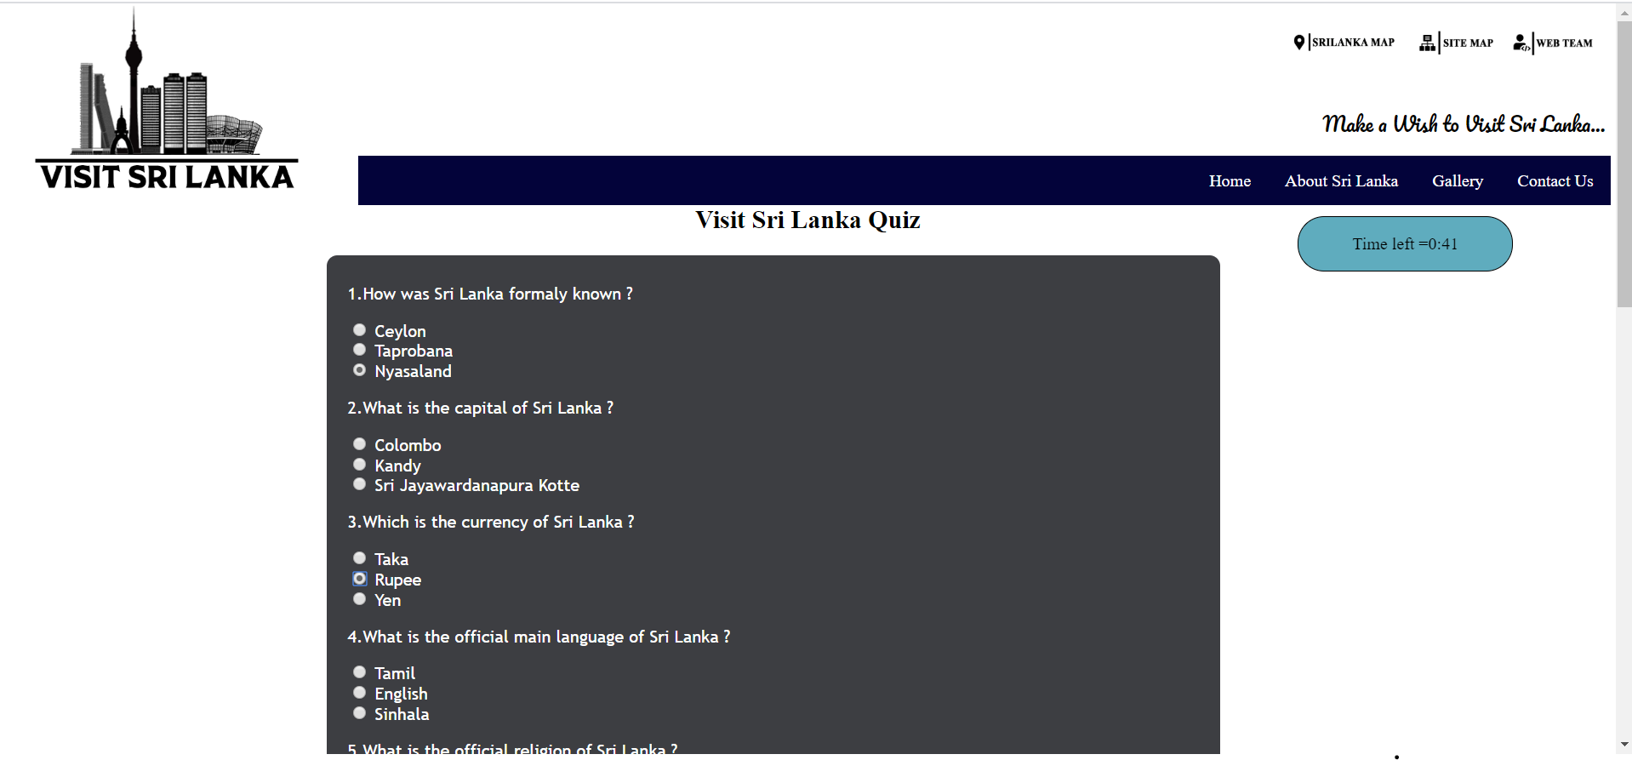

**Problem:**

When window scroll to the down time countdown did not display

**Solution:**

I used external styling sheet and in there I set timer position to fixed.

**CODE:**

body{

font-family: Times New Roman;

margin: 5px;

}

#heading{

text-align:center;

font-weight:bold;

color:black;

}

#quiz {

left:100px;

margin-left: 20%;

background: #3d3e42;

padding: 10px 20px 20px 20px;

width: 800px;

border-radius: 10px;

float:left;

font-family: "Trebuchet MS",Sans-serif;

}

#button {

background:#5FACBE;

border-radius: 5px;

padding: 10px;

color: black;

font-size: 16px;

transition-duration: .5s;

margin-top: 15px;

margin-left: 630px;

}

#button:hover {

background: blue;

border: 2px solid blue;

color: white;

cursor: pointer;

}

#after_submit {

margin-right: auto;

margin-left:30%;

display: none;

background:#ffad33;

padding: 10px 20px 10px 20px;

width: 400px;

border-radius: 20px;

float:left;

font-size: 15px;

}

.timerStyle{

position:fixed;

top:200px;

height: 50px;

width: 200px;

border: 1px solid;

text-align: center;

margin-left: 80%;

background-color:#5FACBE;

border-radius: 25px 25px;

}

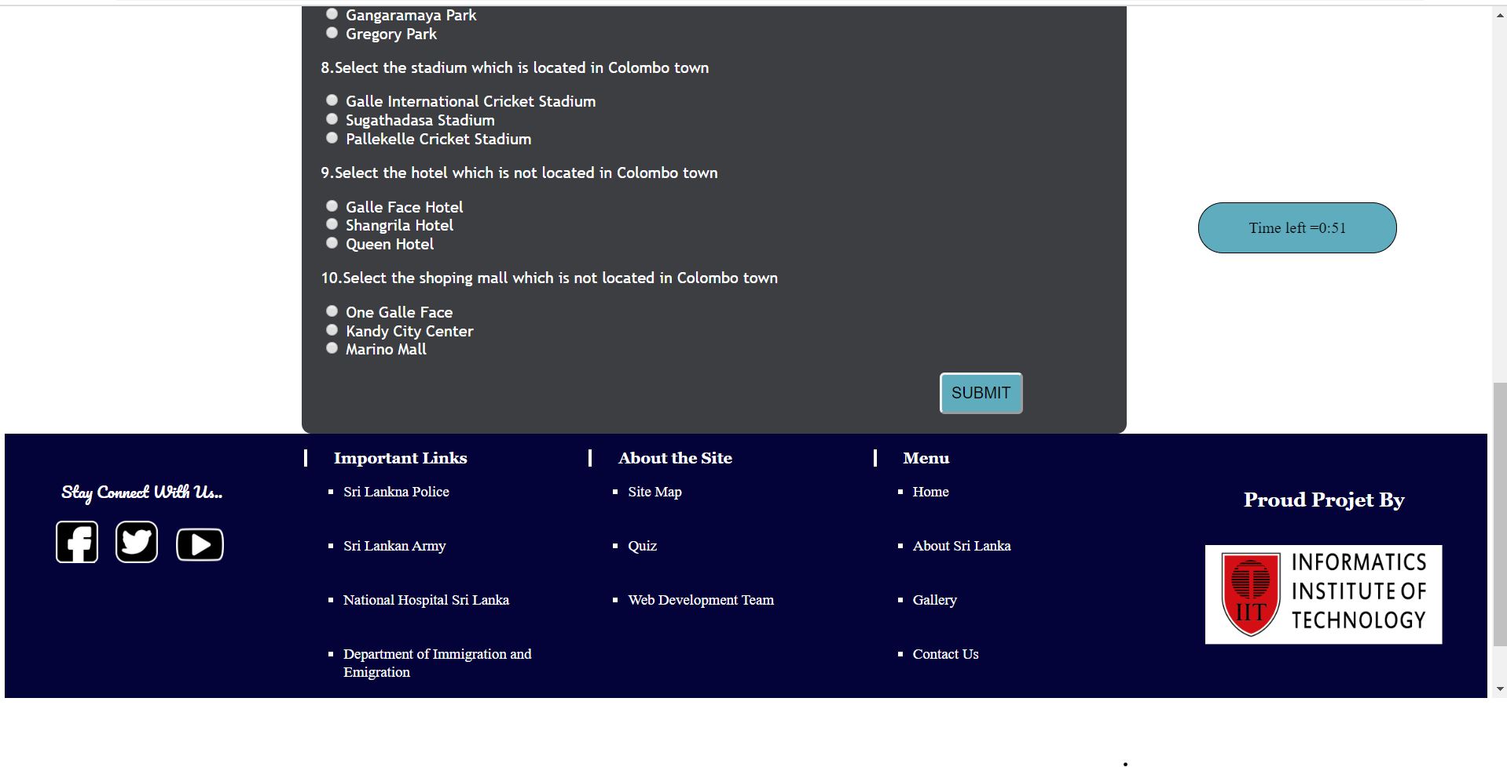

After the quiz according to the user total marks I changed background color.

For that I used javascript. And changed the scene and display the summary of the quiz using javascript.

**CODE:**

//chage background color according to the total marks

if(totalMarks > 11){

document.getElementById("change").style.backgroundColor = "#74D5DD";

document.getElementById("total_marks").innerHTML = "Total marks is " + totalMarks ;

}

if(totalMarks <= 10){

document.getElementById("change").style.backgroundColor = "#FF6961";

document.getElementById("total_marks").innerHTML = "Total marks is " + totalMarks ;

}

//change the scene after submit answers

document.getElementById("quiz").style.display = "none";

document.getElementById("after_submit").style.display = "block";

document.getElementById("number_correct").innerHTML = "You got " + inc + " correct answers.";

document.getElementById("number_incorrect").innerHTML = "You got " + dic + " incorrect answers. ";

document.getElementById("message").innerHTML = answer;

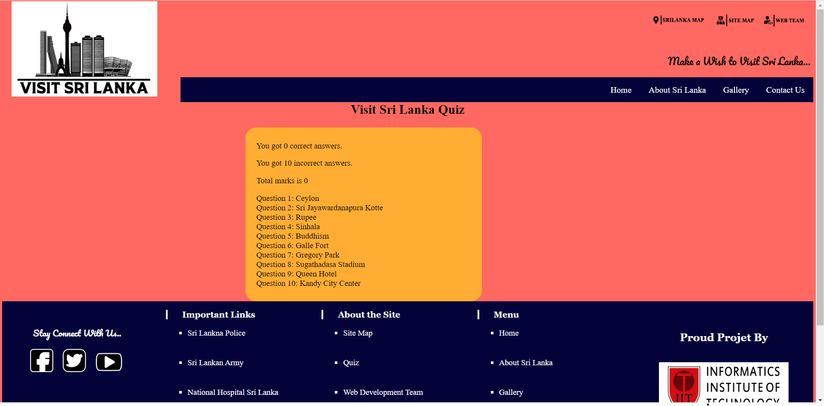

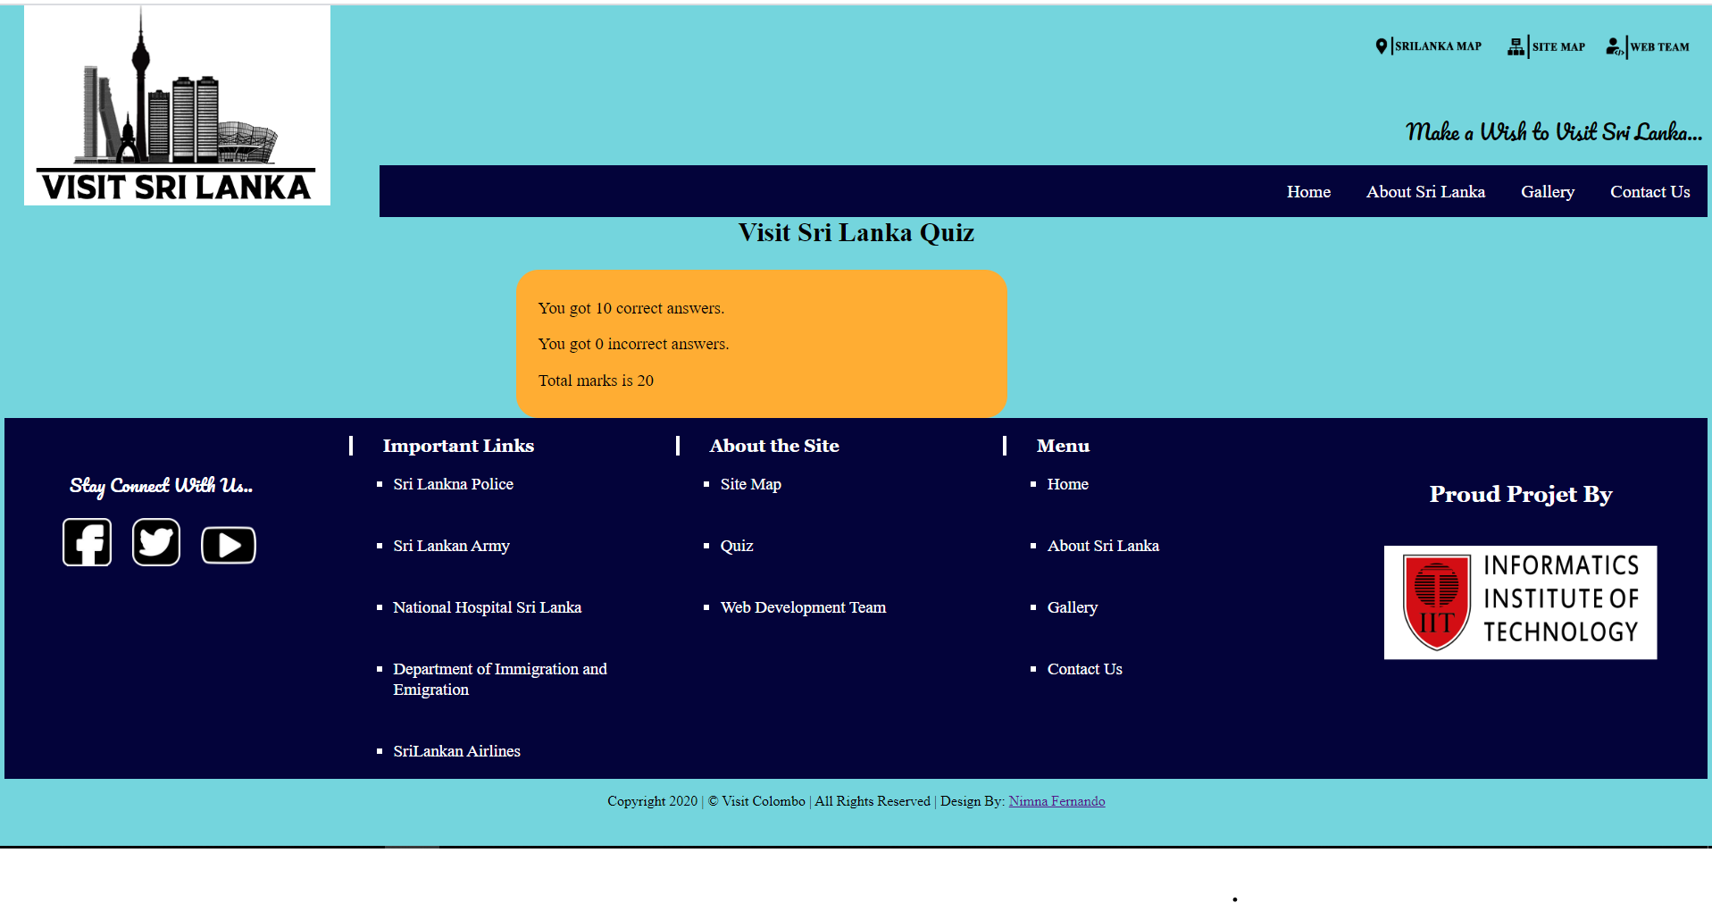

**2.Student Details Page**

Here I made three different html pages for each student and used one external stylesheet for three pages. Using “link” tag linked external style sheets. And I used Image overlay slide to display student’s details. And also I used Unordered list to display students details.

**CODE: link**

<!--External css link to the student detail page-->

<link rel="stylesheet" href="student.css" type="text/css">

**CODE:Unordered list**

<ul>

<li>Name : Nathidu Dias</li>

<li>UoW ID :w1761740</li>

<li>IIT ID :2018455</li>

<li>Student Role:Student 2</li>

</ul>

**CODE: external style sheet**

.container {

position: relative;

left:30%;

width: 50%;

margin:20px;

}

.image {

display: block;

width: 400px;

height: 400px;

box-shadow: 0 0 5px 5px rgba(0, 140, 186, 0.5);

margin:20px;

}

.overlay {

position: absolute;

bottom: 0;

left: 0;

right: 0;

background-color: #AED6F1 ;

overflow: hidden;

width: 0;

height: 100%;

transition: .5s ease;

}

.container:hover .overlay {

width: 50%;

}

.text {

color: white;

font-size: 1.5vw;

position: absolute;

top: 50%;

left: 50%;

-webkit-transform: translate(-50%, -50%);

-ms-transform: translate(-50%, -50%);

transform: translate(-50%, -50%);

white-space: nowrap;

}

#name{

text-align:center;

}

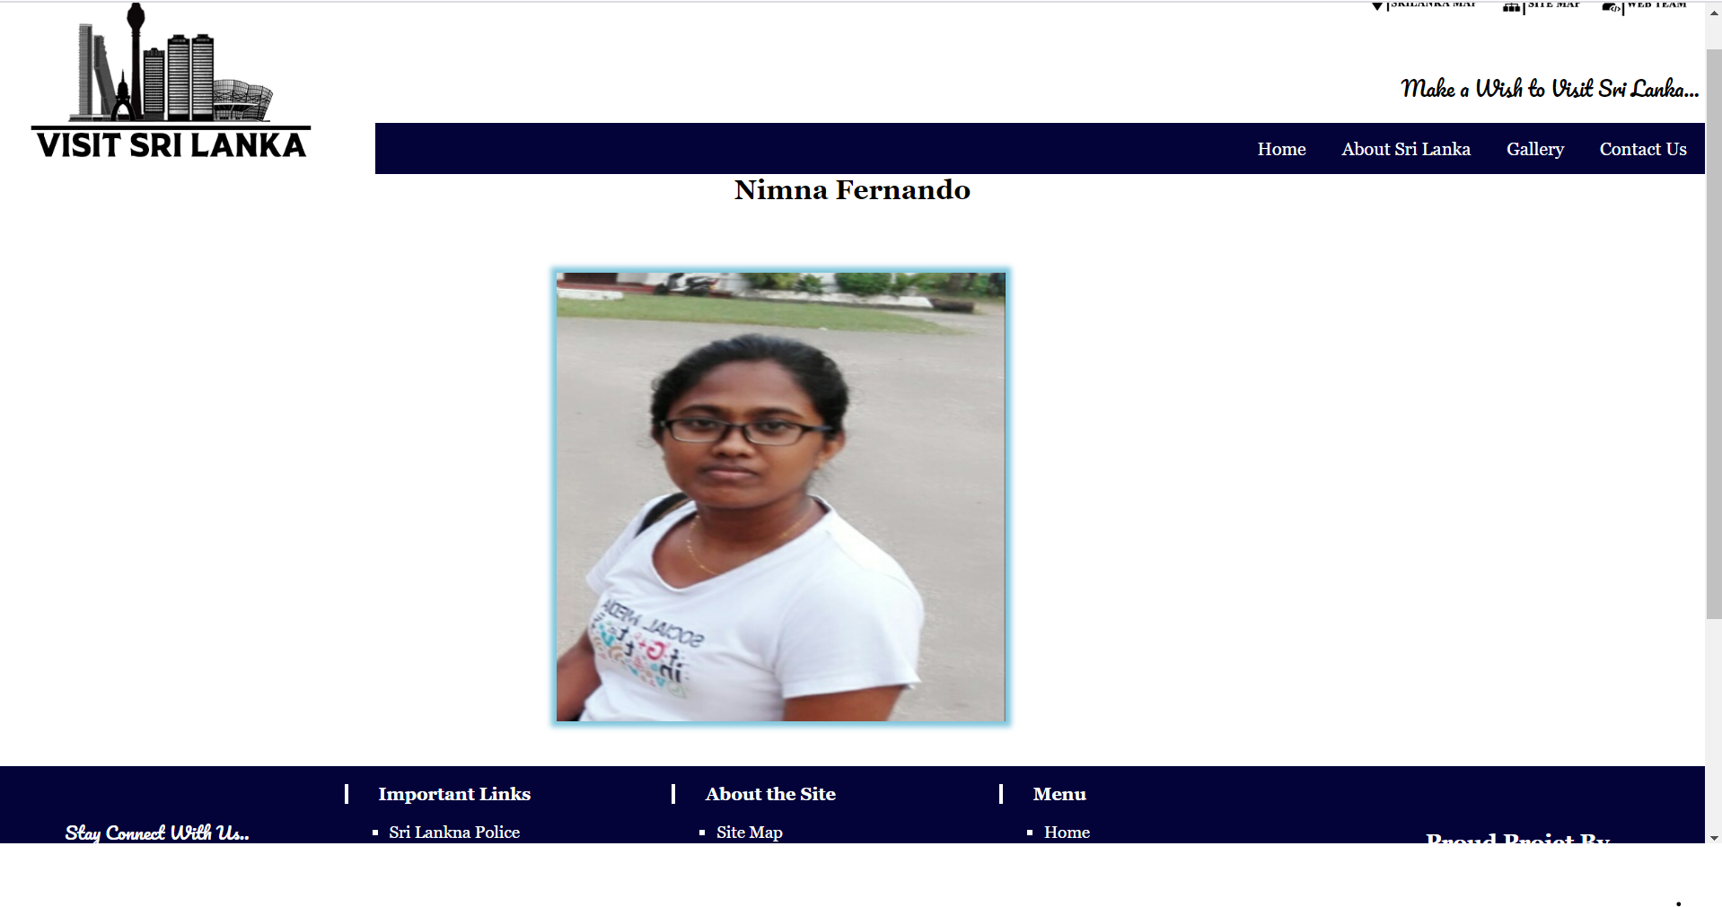

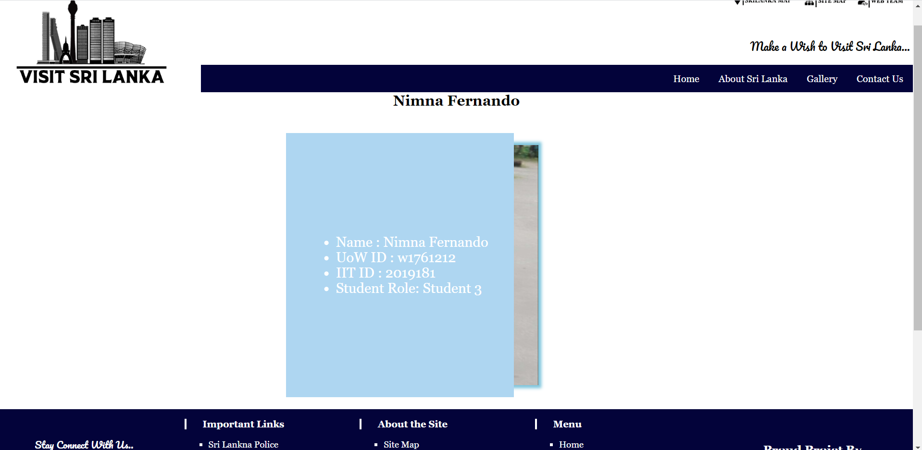

**3.Group Members Page**

Here I used three div tags to separate three images and used same styles for div tags and use css float left .

**CODE: external style sheet**

#place{

float:left;

width:23%;

padding:2%;

margin:20px;

}

}

#name{

text-align:center;

}

.fontType {font-family:Times New Roman;

font-size:1.5vw;}

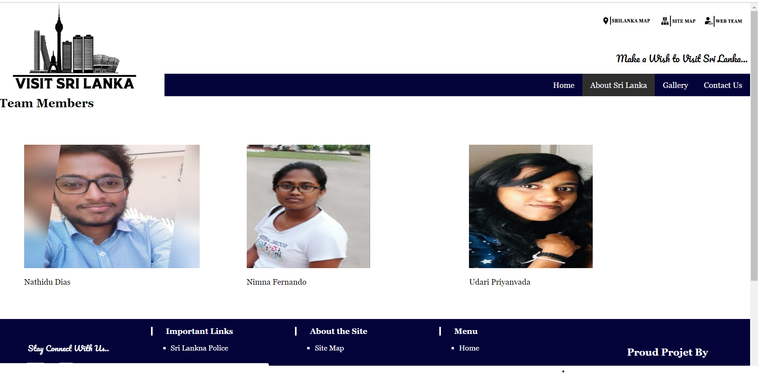

**Part B**

I used menu list top of the page , when click any item in menu they will go to the that area. And I used ” back to top ” link to come back to the page top .

**CODE:**

<h1 >MENU</h1>

<a href="#menu1">Introduction |</a>

<a href="#menu2">History |</a>

<a href="#menu3">Visiting places in Kandy |</a>

<a href="#menu4">Best time to visit Kandy |</a>

<img src="images\icon2.png" width=20 height=20>

<a href="#top">Back to Top</a>

**CODE: html page**

<h2 id="menu3">Visiting places in Kandy</h2>

<div id="place1">

<img src="images/image1.jpg" alt="Temple of the tooth kandy" width="250px" height="250px">

<p class ="fontType2">Temple of the tooth</p>

</div>

<div id="place1">

<img src="images/image2.jpg" alt="Lankhathilaka Viharaya" width="250px" height="250px">

<p class ="fontType2">Lankathilaka Viharaya</p>

</div>

**CODE: css**

1.Here I used div classes to separate images in “visiting places in kandy”. Used css float : left

#place1{

float:left;

width:23%;

padding:1%;

}

2.set responsive text size for heading.

#text{

color: blue;

text-align:center;

font-size:2.5vw;

top:20px;

}

3.And for main image I used opacity= 0.65 to change view of image.

#image{

opacity:0.65;

vertical-align:middle;

height:300px;

width:1200px

}

4. Used one div tag to display content of the body

#column2{float:left;

width:90%;

padding:1%;

padding:60px;

}

5.Used css rounded boarder to display “Best palces visit” area.

.time{

border:2px solid blue;

border-radius:25px; /*CSS Rounded Border*/

text-align: center;

padding:1%; /*CSS Padding*/

box-shadow: 10px 10px 5px grey; /*CSS Box Shadow*/

width:100%;

}

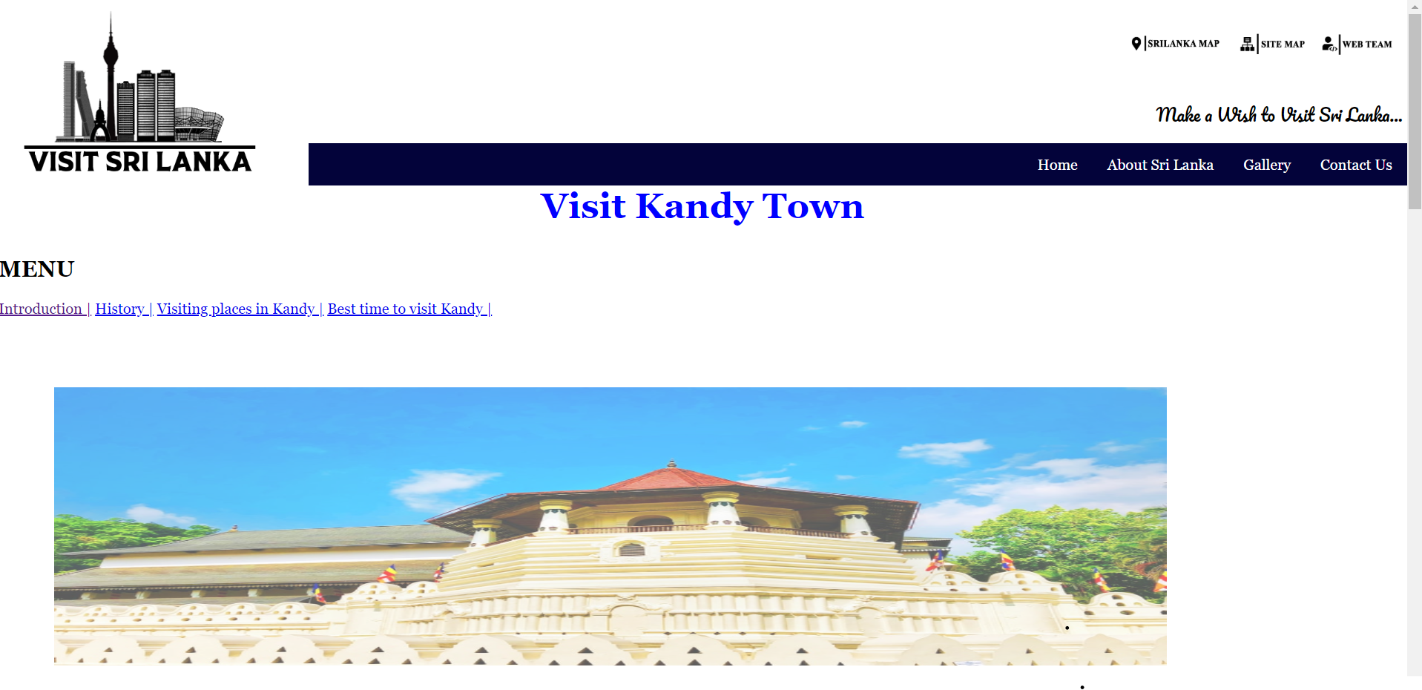

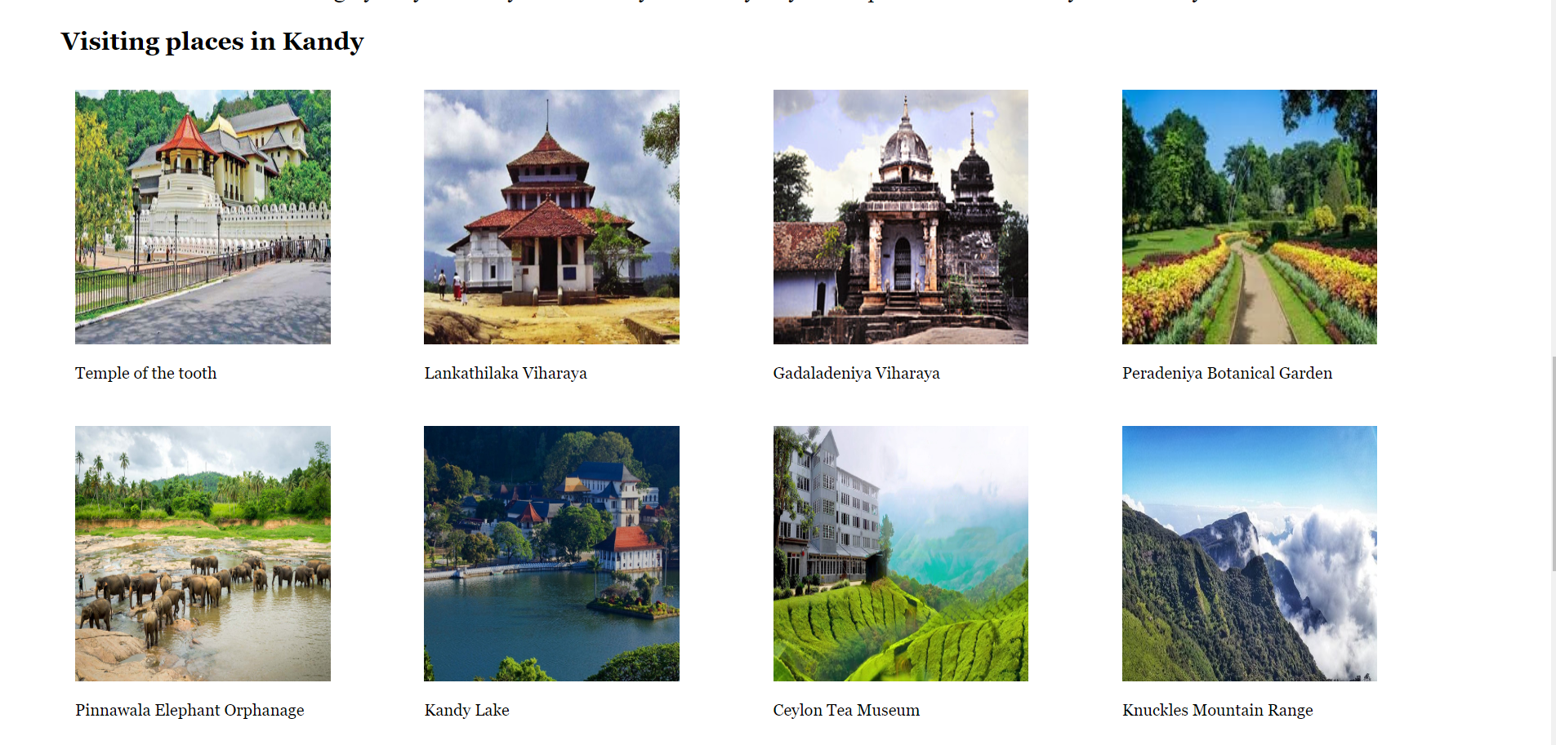

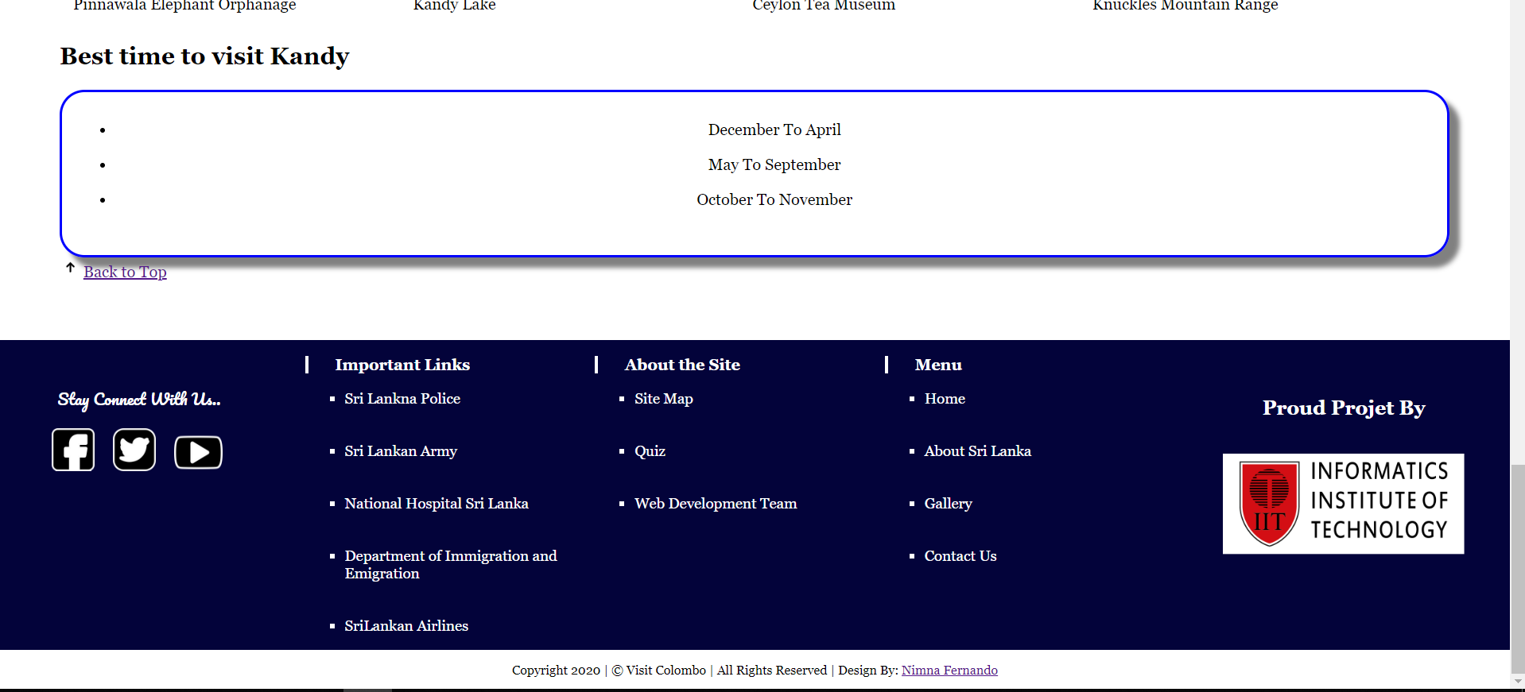

--------------------------------------------------------------------------------------------------------------------------

# Discussion of UI and application of UX principles

Our web site is about visit Sri Lanka. So this web site should be attractive , eye catching and need to be simple. And web site need to have well organized and web page contents need to have legibility also. So then web page can influence users emotions and perceptions.

In our web page layout designed using dark blue , black and to design logo used black, grey and white so, in body I mainly used white to the background color. So it’s very easy to users. Any age group people can use web site and get general knowledge. And also mainly used black as font color it also help to increase eye catching. Used middle large font size to display fonts clearly.



Mainly we used images to give details about places and events without using lots of text areas.

Used good quality images to achieve to make a decision for user.

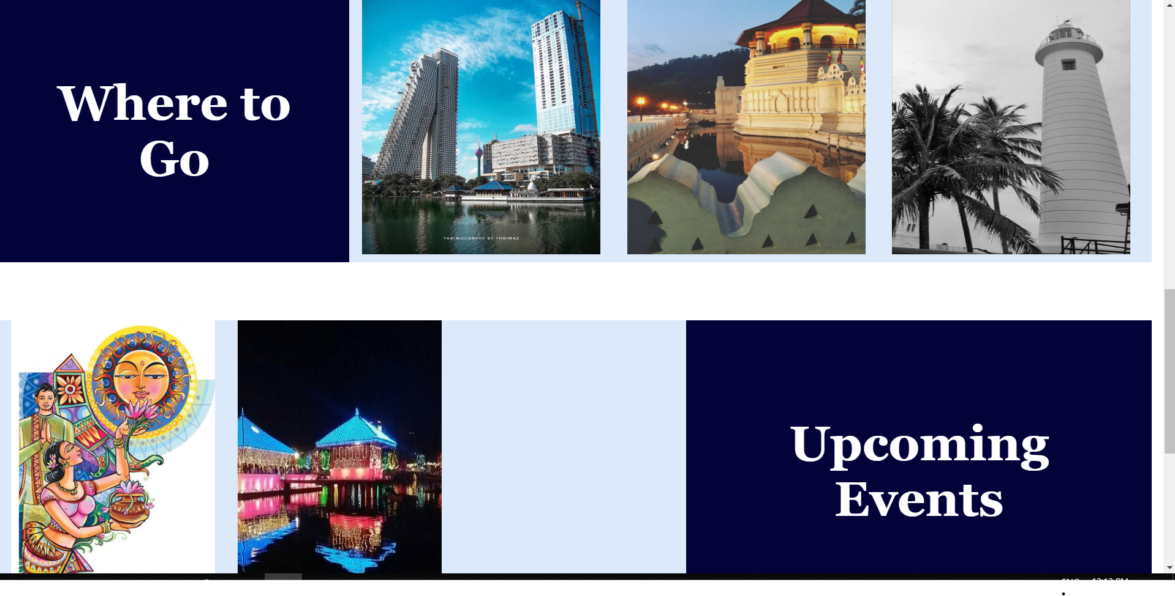

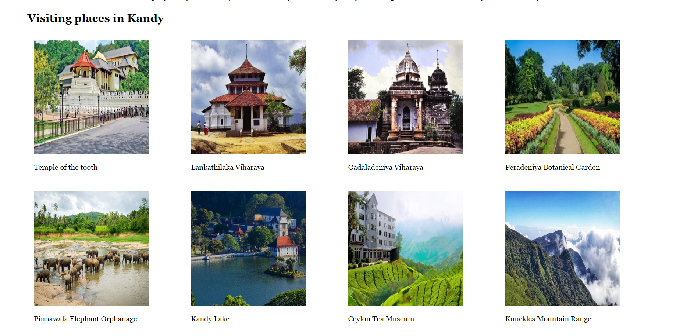

And also used symbols to give paths or quick access links. And also it helps to keep web site simple.



---------------------------------------------------------------------------------------------------------------------------

## 

## 3.1 Information architecture

### a. Design

As Student 3 I created Quiz page , student details form. And the individual page. And also I created one page to view all group members. And also we used one folder to hold every images.

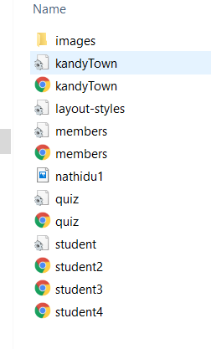

And used one layout for all pages in web sites. Using this navigation bar user can simply change the path what ever the place inside web page.

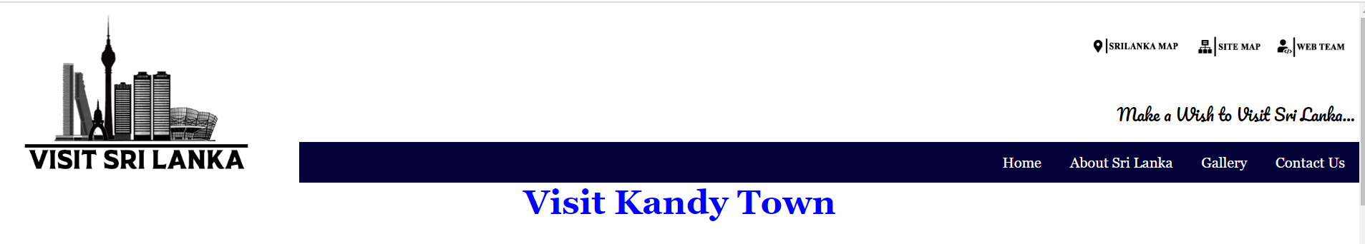



Bottom of every page there is a link to show page editor .

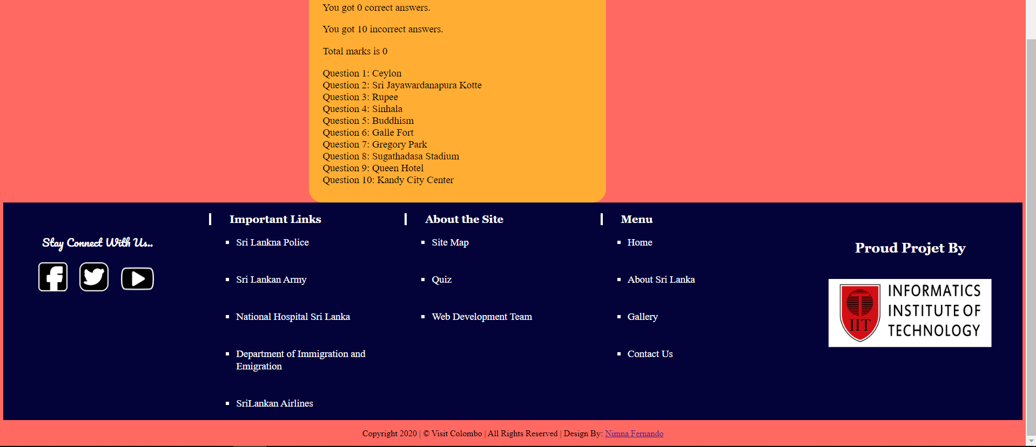

In main page shows a label ”Where to Go” and three images onclicking that image text user can move to the individual pages.



--------------------------------------------------------------------------------------------------------------------------

### b. Code to achieve good Information architecture

1.Main page link to the Home Page, About Sri Lanka Page, Gllery and Contact us.

<!--Main Menu-->

<div class="main-menu-div">

<div class="menu" id="mainmenu">

<a href="index.html">Home</a>

<a href="about.html">About Sri Lanka</a>

<a href="gallery.html">Gallery</a>

<a href="contact.html">Contact Us</a>

</div>

</div>

2.Main page link to the web quiz.

<div class="quiz">

<div class="heading">

<p>Want to Check Your Knowladge..?</p>

</div>

<div class="button-about">

<a href="quiz.html" class="buttoninabout">Click Me</a>

</div>

</div>

3.Link to the page editor page.

<div class="copyrights-note">

<p id="copyrights-note-text">Copyright 2020 | &copy; Visit Colombo | All Rights Reserved | Design By: <a href="student3.html">Nimna Fernando</a></p>

</div>

4.Link to move individual pages.

<div class="container">

<div class="image"><img src="images/grid-2.jpeg"></div>

<div class="overlayfx">

<div class="text">

<a href="kandytown.html">Kandy City</a>

</div>

</div>

</div>

## 3.2 Colour balance/composition/graphics/consistency

### a. Design

Accoring to the our web page it’s colours need to be simple.

Use simple colours to design web site. We used “#03033a” colour code to the navigation bar.

And to design logo used black, grey and white.

To increase sufficient contrast and eye catching we mostly used more white space through the web site. And use more white padding around the images.

Other than that in quiz page I used “#3d3e42” colour code as background colour of quiz form.

According to the user quiz marks I changed page background colour.

If marks greater than 11 then change page background colour to this colour “#74D5DD” or marks less than or equals to 10 then change background colour to this ”#FF6961” .

To view student details I used image overlay slide.

--------------------------------------------------------------------------------------------------------------------------

### b. Code to achieve good colour balance & ensure consistency

Used white background space to separate navigation bar and body content, because to design navigation bar and footer we used black and white.

1.Quiz form background colour

#quiz {

left:100px;

margin-left: 20%;

background: #3d3e42;

padding: 10px 20px 20px 20px;

width: 800px;

border-radius: 10px;

float:left;

font-family: "Trebuchet MS",Sans-serif;

}

2.Quiz timer colours

.timerStyle{

position:fixed;

top:200px;

height: 50px;

width: 200px;

border: 1px solid;

text-align: center;

margin-left: 80%;

background-color:#5FACBE;

border-radius: 25px 25px;

}

3.Quiz form background colour after the submit answers.

#after_submit {

margin-right: auto;

margin-left:30%;

display: none;

background:#ffad33;

padding: 10px 20px 10px 20px;

width: 400px;

border-radius: 20px;

float:left;

font-size: 15px;

}

4.Quiz button colours

#button {

background:#5FACBE;

border-radius: 5px;

padding: 10px;

color: black;

font-size: 16px;

transition-duration: .5s;

margin-top: 15px;

margin-left: 630px;

}

#button:hover {

background: blue;

border: 2px solid blue;

color: white;

cursor: pointer;

}

--------------------------------------------------------------------------------------------------------------------------

### c. Colour contrast test results

Section guidelines: Text vs background colour contrast. Include screen shot of test results from a colour contrast checking tool such as: <https://snook.ca/technical/colour_contrast/colour.html#fg=FFFFFE,bg=000000>

## Typography / consistency

### Design

Used enough contrast so it increase text is legible. I separated headings and content clearly to increase consistency . And I did not used more text fields or paragraphs inside the web page.

And I separated paragraph to increase readability.

### Code to achieve good typography / consistency

1.CSS code for the quiz page

#quiz {

left:100px;

margin-left: 20%;

background: #3d3e42;

padding: 10px 20px 20px 20px;

width: 800px;

border-radius: 10px;

float:left;

font-family: "Trebuchet MS",Sans-serif;

}

body{

font-family: Times New Roman;

margin: 5px;

}

#heading{

text-align:center;

font-weight:bold;

color:black;

}

2.CSS code for student details page

.container {

position: relative;

left:30%;

width: 50%;

margin:20px;

}

.image {

display: block;

width: 400px;

height: 400px;

box-shadow: 0 0 5px 5px rgba(0, 140, 186, 0.5);

margin:20px;

}

.text {

color: white;

font-size: 1.5vw;

position: absolute;

top: 50%;

left: 50%;

-webkit-transform: translate(-50%, -50%);

-ms-transform: translate(-50%, -50%);

transform: translate(-50%, -50%);

white-space: nowrap;

}

#name{

text-align:center;

}

3.CSS for members styles

#place{

float:left;

width:23%;

padding:2%;

margin:20px;

}

}

#name{

text-align:center;

}

.fontType{font-family:Times New Roman;

font-size:1.5vw;}

I used ACHECKER web site to test the legibility of web page.

But it did not show any errors according to my web site pages.

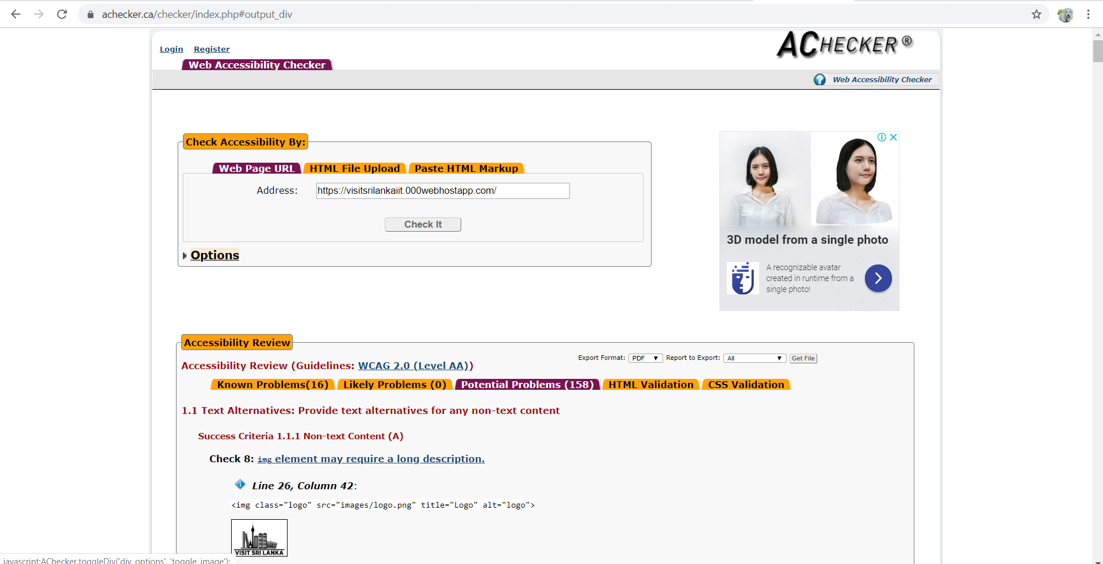

---------------------------------------------------------------------------------------------------------------------------

## Gestalt principles grouping

Gestalt Proximity is an idea that when objects are placed near one another .

I used div tags to make Part B web page.

In Part B web page I used one div tag to include all the content.

Inside main div tag I separated body mainly into three parts. In part one contain descriptions of the page (Introduction and History).

In second part I used mainly four columns to display images separately. For that again I used four div tags.

And in the last area I used rounded box to display best time to visit Kandy and back to top link.

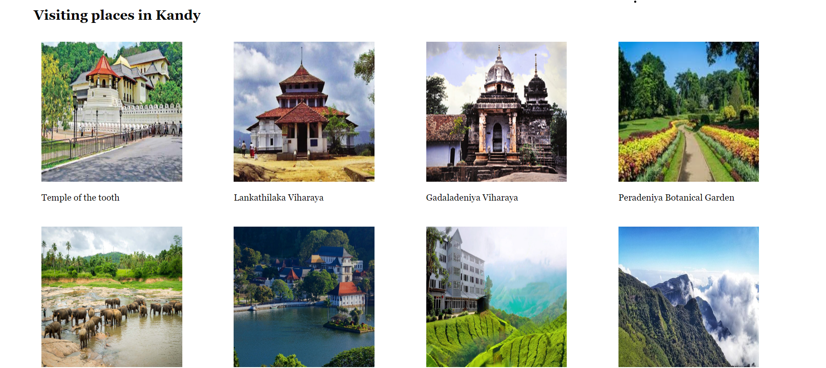

To avoid the similarity between images I used padding.

**CSS CODE:**

#place1{

float:left;

width:23%;

padding:1%;

}

--------------------------------------------------------------------------------------------------------------------------

## 3.5 Accessibility (graphics/forms)

### a. Graphical elements - Design/Code

I used “alt ” attribute for every images. So It shows the users the image name or required information when image is not available.

**CODE**

<img src="images\nathiduS2.jpeg" alt="Nathidu:2018455" class="image">

### Form completion - Design/Code

In my quiz web site for timer I position to fix .So when page scroll down the timer also go down . So it’s helpful to users to view time count down.

## 3.6 Error prevention and recovery

### a. Design

Section guidelines:

* In cases of form completing how did you assist the user to complete all the required field, to enter the information correctly and eliminate error and how did you address error recovery? E.g., did you use any instructions for completing the form? Did you provide any meaningful error messages in case the users did not completed the form correctly to help them correct their mistakes?
* How have you addressed accessibility in the design. E.g., instructions for form completion, inclusion of images for descriptive or decorative purposes, or system response and error messages.
* Illustrate your discussion with screenshots.

--------------------------------------------------------------------------------------------------------------------------

### b. Code to address error prevention and recovery

Section guidelines: Provide the code you used to address accessibility, e.g. for form completion, graphics, or system response and error messages.





And also I used button hover to the submit button.

#button {

background:#5FACBE;

border-radius: 5px;

padding: 10px;

color: black;

font-size: 16px;

transition-duration: .5s;

margin-top: 15px;

margin-left: 630px;

}

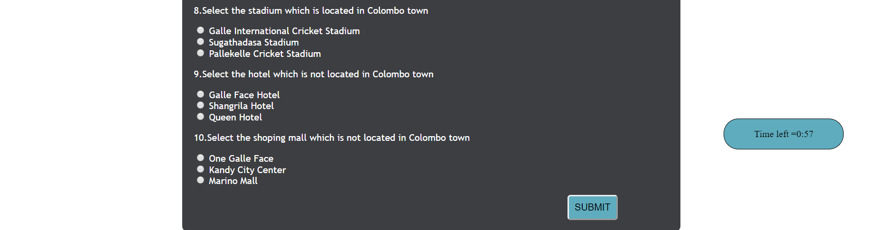

#button:hover {

background: blue;

border: 2px solid blue;

color: white;

cursor: pointer;

}

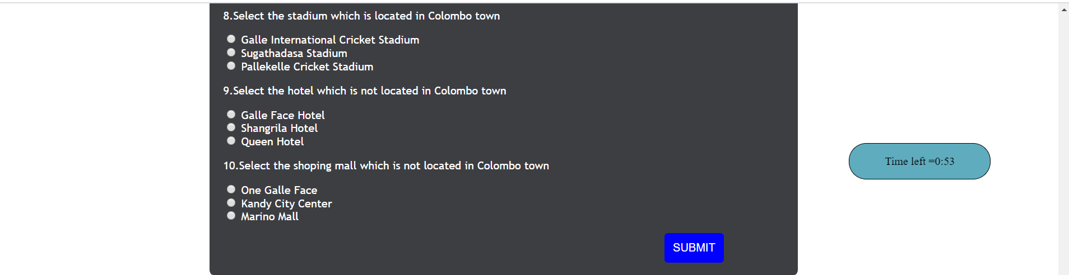

# Janet

Janet is a high speed network for the UK research and education community provided by jisc.

According to Janet regulation I may not use any offensive or indecent images, data or other materials. And as a team we created this web site for completely our academic purpose. So in our web site do not collect any data of users.

And there is no any virus created systems.

# Conclusions

As a team we planed to complete our course work on time. But unfortunately one of our team member (student 1) at the last moment decided to hold his degree and he informed us it last day. So we are unable to complete student one part. But I created a one page to display group members page.

But as a team we faced that problem successfully.

When I am doing this coursework it helped me to improve team work qualities. As a team we helped each other to complete work.

When I was doing this coursework It improved my html and javascript knowledge.

# References

W3schools

# Appendices

## Appendix A: Code

**Part A**

**Quiz page :quiz.html**

<!DOCTYPE html>

<html>

<head>

<!--Favicon Image-->

<link rel="icon" href="images/favicon.png" type="image/png" sizes="16x16">

<!--Title-->

<title>Home | Visit Sri Lanka</title>

<!--External Css Link-->

<link rel="stylesheet" href="layout-styles.css" type="text/css">

<!--Importing Fonts-->

<link href="https://fonts.googleapis.com/css?family=Pacifico&display=swap" rel="stylesheet">

<!--Setting the view point-->

<meta name="viewport" content="width=device-width, initial-scale=1.0">

<!--link quiz page extaenal style sheet-->

<<link href ="quiz.css" rel ="stylesheet">

</head>

<body>

<header>

<div class="header">

<!--Logo-->

<div class="logo-div">

<img class="logo" src="images/logo.png" title="Logo" alt="logo">

</div>

<!--Site Map and Team button-->

<div class="site-mapicon-div">

<a href="https://www.google.lk/maps/place/Sri+Lanka/@7.8517307,78.46154,7z/data=!3m1!4b1!4m5!3m4!1s0x3ae2593cf65a1e9d:0xe13da4b400e2d38c!8m2!3d7.873054!4d80.771797" target="_blank"><img id="mapicon" title="Colombo Map" alt="Colomo Map button" src="images/mapicon.png"></a>

<a href="#sitemap"><img id="sitemapicon" title="Site Map" alt="Site Map button" src="images/sitemap.png"></a>

<a href="#web team"><img id="teamicon" title="Web Team" alt="Web Team button" src="images/team.png"></a>

</div>

<!--Welcome Text-->

<div class="welcome-text-div">

<p id="welcome-text">Make a Wish to Visit Sri Lanka...</p>

</div>

<!--Main Menu-->

<div class="main-menu-div">

<div class="menu" id="mainmenu">

<a href="#home" class="active">Home</a>

<a href="#news">About Colombo</a>

<a href="#contact">Gallery</a>

<a href="#about">Contact Us</a>

</div>

</div>

</div>

</header>

<!------------------------------------------------------------------------------------------------------->

<!------------------------------------------------------------------------------------------------------->

<!------------------------------------------------------------------------------------------------------->

<section>

<script>

function check(){

window.scrollTo(0,0);

document.getElementById('time').style.display="none";

var ques1 = document.quiz.ques1.value;

var ques2 = document.quiz.ques2.value;

var ques3 = document.quiz.ques3.value;

var ques4 = document.quiz.ques4.value;

var ques5 = document.quiz.ques5.value;

var ques6 = document.quiz.ques6.value;

var ques7 = document.quiz.ques7.value;

var ques8 = document.quiz.ques8.value;

var ques9 = document.quiz.ques9.value;

var ques10 = document.quiz.ques10.value;

// set correct answers in to the array

var message=["Question 1: Ceylon<br>","Question 2: Sri Jayawardanapura Kotte<br>","Question 3: Rupee<br>","Question 4: Sinhala<br>","Question 5: Buddhism<br>","Question 6: Galle Fort<br>","Question 7: Gregory Park<br>","Question 8: Sugathadasa Stadium<br>","Question 9: Queen Hotel<br>","Question 10: Kandy City Center<br>"];

var answer= " ";

var inc =0; //no of correct answers

var dic =0; //no of incorrect answers

var correctMarks = 0;

var incorretMarks = 0;

if (ques1 == "Ceylon") {

correctMarks=correctMarks+2;

inc++;

}else {

dic++;

answer += message[0];

incorretMarks--;

}

if (ques2 == "Sri Jayawardanapura Kotte") {

correctMarks=correctMarks+2;

inc++;

}else {

dic++;

answer += message[1];

incorretMarks--;

}

if (ques3 == "Rupee") {

correctMarks=correctMarks+2;

inc++;

}else {

dic++;

answer += message[2];

incorretMarks--;

}

if (ques4 == "Sinhala") {

correctMarks=correctMarks+2;

inc++;

}else {

dic++;

answer += message[3];

incorretMarks--;

}

if (ques5 == "Buddhism") {

correctMarks=correctMarks+2;

inc++;

} else{

dic++;

answer += message[4];

incorretMarks--;

}

if (ques6 == "Galle Fort") {

correctMarks=correctMarks+2;

inc++;

}else{

dic++;

answer += message[5];

incorretMarks--;

}

if (ques7 == "Gregory Park") {

correctMarks=correctMarks+2;

inc++;

}else{

dic++;

answer += message[6];

incorretMarks--;

}

if (ques8 == "Sugathadasa Stadium") {

correctMarks=correctMarks+2;

inc++;

} else {

dic++;

answer += message[7];

incorretMarks--;

}

if (ques9 == "Queen Hotel") {

correctMarks=correctMarks+2;

inc++;

}else{

dic++;

answer += message[8];

incorretMarks--;

}

if (ques10 == "Kandy City Center") {

correctMarks=correctMarks+2;

inc++;

}else{

dic++;

answer += message[9];

incorretMarks--;

}

var totalMarks =0 ;

if(correctMarks >= dic){

totalMarks = correctMarks - dic;

}

if(correctMarks < dic){

totalMarks = 0;

}

//chage background color according to the total marks

if(totalMarks > 11){

document.getElementById("change").style.backgroundColor = "#74D5DD";

document.getElementById("total_marks").innerHTML = "Total marks is " + totalMarks ;

}

if(totalMarks <= 10){

document.getElementById("change").style.backgroundColor = "#FF6961";

document.getElementById("total_marks").innerHTML = "Total marks is " + totalMarks ;

}

//change the scene after submit answers

document.getElementById("quiz").style.display = "none";

document.getElementById("after_submit").style.display = "block";

document.getElementById("number_correct").innerHTML = "You got " + inc + " correct answers.";

document.getElementById("number_incorrect").innerHTML = "You got " + dic + " incorrect answers. ";

document.getElementById("message").innerHTML = answer;

}

//set timer to one minite duration

function counterStart(){

document.getElementById("timer").innerHTML = "Time left ="+ 00 + ":" + 60 ;

startTimer();

}

function startTimer() {

var presentTime = document.getElementById('timer').innerHTML;

var timeArray = presentTime.split(/[:]+/);

var minite = timeArray[0]; //time array 0 index assign to variable minite

var second = checkSecond((timeArray[1] - 1)); // time array 1 index assign to variable second

// if second equlas to 0 then call check function

if(second==0)

{

check();

}

document.getElementById("timer").innerHTML = minite + ":" + second;

setTimeout(startTimer, 1000);

}

function checkSecond(sec) {

if (sec < 10 && sec >= 0)

{sec = "0" + sec;}

if (sec < 0)

{sec = "59";}

return sec;

}

</script>

<body id="change" onload="counterStart()">

<h1 id="heading"> Visit Sri Lanka Quiz</h1>

<div class="timerStyle" id="time">

<p id="timer">

</p>

</div>

<form id = "quiz" name = "quiz">

<font color="#ffffff">

<p class="question">1.How was Sri Lanka formaly known ?</p>

<input type = "radio" id = "selection" name = "ques1" value = "Ceylon"> Ceylon<br>

<input type = "radio" id = "selection" name = "ques1" value = "Taprobana"> Taprobana<br>

<input type = "radio" id = "selection" name = "ques1" value = "Nyasaland"> Nyasaland<br>

<p class="question">2.What is the capital of Sri Lanka ?</p>

<input type = "radio" id = "selection" name = "ques2" value = "Colombo"> Colombo<br>

<input type = "radio" id = "selection" name = "ques2" value = "Kandy"> Kandy<br>

<input type = "radio" id = "selection" name = "ques2" value = "Sri Jayawardanapura Kotte"> Sri Jayawardanapura Kotte<br>

<p class="question">3.Which is the currency of Sri Lanka ?</p>

<input type = "radio" id = "selection" name = "ques3" value = "Taka"> Taka<br>

<input type = "radio" id = "selection" name = "ques3" value = "Rupee"> Rupee<br>

<input type = "radio" id = "selection" name = "ques3" value = "Yen"> Yen<br>

<p class="question">4.What is the official main language of Sri Lanka ?</p>

<input type = "radio" id = "selection" name = "ques4" value = "Tamil"> Tamil<br>

<input type = "radio" id = "selection" name = "ques4" value = "English"> English<br>

<input type = "radio" id = "selection" name = "ques4" value = "Sinhala"> Sinhala<br>

<p class="question">5.What is the official religion of Sri Lanka ?</p>

<input type = "radio" id = "selection" name = "ques5" value = "Buddhism"> Buddhism<br>

<input type = "radio" id = "selection" name = "ques5" value = "Hinduism"> Hinduism<br>

<input type = "radio" id = "selection" name = "ques5" value = "Christianity"> Christianity<br>

<p class="question">6.Select the place which is not located in Colombo town</p>

<input type = "radio" id = "selection" name = "ques6" value = "Lotus Tower"> Lotus Tower<br>

<input type = "radio" id = "selection" name = "ques6" value = "Galle Fort"> Galle Fort<br>

<input type = "radio" id = "selection" name = "ques6" value = "Galle Face"> Galle Face<br>

<p class="question">7.Select the park which is not located in Colombo town</p>

<input type = "radio" id = "selection" name = "ques7" value = "Viharamahadevi Park"> Viharamahadevi Park<br>

<input type = "radio" id = "selection" name = "ques7" value = "Gangaramaya Park"> Gangaramaya Park<br>

<input type = "radio" id = "selection" name = "ques7" value = "Gregory Park"> Gregory Park<br>

<p class="question">8.Select the stadium which is located in Colombo town</p>

<input type = "radio" id = "selection" name = "ques8" value = "Galle International Cricket Stadium"> Galle International Cricket Stadium<br>

<input type = "radio" id = "selection" name = "ques8" value = "Sugathadasa Stadium"> Sugathadasa Stadium<br>

<input type = "radio" id = "selection" name = "ques8" value = "Pallekelle Cricket Stadium"> Pallekelle Cricket Stadium<br>

<p class="question">9.Select the hotel which is not located in Colombo town</p>

<input type = "radio" id = "selection" name = "ques9" value = "Galle Face Hotel"> Galle Face Hotel<br>

<input type = "radio" id = "selection" name = "ques9" value = "Shangrila Hotel"> Shangrila Hotel<br>

<input type = "radio" id = "selection" name = "ques9" value = "Queen Hotel"> Queen Hotel<br>

<p class="question">10.Select the shoping mall which is not located in Colombo town</p>

<input type = "radio" id = "selection" name = "ques10" value = "One Galle Face"> One Galle Face<br>

<input type = "radio" id = "selection" name = "ques10" value = "Kandy City Center"> Kandy City Center<br>

<input type = "radio" id = "selection" name = "ques10" value = "Marino Mall"> Marino Mall<br>

<!--set onAction to the button-->

<input id = "button" type = "button" value = "SUBMIT" onclick = "check()" align="right">

</font>

</form>

<div id = "after_submit">

<p id = "number_correct"></p>

<p id = "number_incorrect"></p>

<p id = "total_marks"></p>

<p id = "message"></p>

</div>

</body>

</section>

<!------------------------------------------------------------------------------------------------------->

<!------------------------------------------------------------------------------------------------------->

<!------------------------------------------------------------------------------------------------------->

<footer>

<div class="footer">

<div class="social-links">

<p>Stay Connect With Us..</p>

<a href="#fb"><img id="fb-icon" title="Facebook" alt="Facebook button" src="images/facebook.png"></a>

<a href="#twitter"><img id="twitter-icon" title="Twitter" alt="Twitter button" src="images/twitter.png"></a>

<a href="#youtube"><img id="youtube-icon" title="Youtube" alt="Youtube button" src="images/youtube.png"></a>

</div>

<div class="navi-links">

<div class="impotant-links">

<p>Important Links</p>

<ul>

<li><a href="https://www.police.lk/" target="_blank">Sri Lankna Police</a></li><br><br>

<li><a href="https://www.army.lk/" target="_blank">Sri Lankan Army</a></li><br><br>

<li><a href="http://www.nhsl.health.gov.lk/" target="_blank">National Hospital Sri Lanka</a></li><br><br>

<li><a href="http://www.immigration.gov.lk/" target="_blank">Department of Immigration and Emigration</a></li><br><br>

<li><a href="https://www.srilankan.com/en_uk/lk" target="_blank">SriLankan Airlines</a></li>

</ul>

</div>

<div class="about-site">

<p>About the Site</p>

<ul>

<li><a href="#home">Site Map</a></li><br><br>

<li><a href="#home">Quiz</a></li><br><br>

<li><a href="#home">Web Development Team</a></li>

</ul>

</div>

<div class="page-links">

<p>Menu</p>

<ul>

<li><a href="#home">Home</a></li><br><br>

<li><a href="#home">About Colombo</a></li><br><br>

<li><a href="#home">Gallery</a></li><br><br>

<li><a href="#home">Contact Us</a></li>

</ul>

</div>

</div>

<div class="down-logo">

<p>Proud Projet By</p>

<img id="footer-logo" src="images/iit-logo.png" title="IIT Logo" alt="IIT LOGO">

</div>

</div>

<div class="copyrights-note">

<p id="copyrights-note-text">Copyright 2020 | &copy; Visit Colombo | All Rights Reserved</p>

</div>

</footer>

</body>

</html>

**quiz.css**

**body{**

**font-family: Times New Roman;**

**margin: 5px;**

**}**

**#heading{**

**text-align:center;**

**font-weight:bold;**

**color:black;**

**}**

**#quiz {**

**left:100px;**

**margin-left: 20%;**

**background: #3d3e42;**

**padding: 10px 20px 20px 20px;**

**width: 800px;**

**border-radius: 10px;**

**float:left;**

**font-family: "Trebuchet MS",Sans-serif;**

**}**

**#button {**

**background:#5FACBE;**

**border-radius: 5px;**

**padding: 10px;**

**color: black;**

**font-size: 16px;**

**transition-duration: .5s;**

**margin-top: 15px;**

**margin-left: 630px;**

**}**

**#button:hover {**

**background: blue;**

**border: 2px solid blue;**

**color: white;**

**cursor: pointer;**

**}**

**#after_submit {**

**margin-right: auto;**

**margin-left:30%;**

**display: none;**

**background:#ffad33;**

**padding: 10px 20px 10px 20px;**

**width: 400px;**

**border-radius: 20px;**

**float:left;**

**font-size: 15px;**

**}**

**.timerStyle{**

**position:fixed;**

**top:200px;**

**height: 50px;**

**width: 200px;**

**border: 1px solid;**

**text-align: center;**

**margin-left: 80%;**

**background-color:#5FACBE;**

**border-radius: 25px 25px;**

**}**

**Student details**

**Student2.html**

<!DOCTYPE html>

<html>

<head>

<!--Favicon Image-->

<link rel="icon" href="images/favicon.png" type="image/png" sizes="16x16">

<!--Title-->

<title>Home | Visit Sri Lanka</title>

<!--External Css Link-->

<link rel="stylesheet" href="layout-styles.css" type="text/css">

<!--Importing Fonts-->

<link href="https://fonts.googleapis.com/css?family=Pacifico&display=swap" rel="stylesheet">

<!--Setting the view point-->

<meta name="viewport" content="width=device-width, initial-scale=1.0">

<!--External css link to the student detail page-->

<link rel="stylesheet" href="student.css" type="text/css">

</head>

<body>

<header>

<div class="header">

<!--Logo-->

<div class="logo-div">

<img class="logo" src="images/logo.png" title="Logo" alt="logo">

</div>

<!--Site Map and Team button-->

<div class="site-mapicon-div">

<a href="https://www.google.lk/maps/place/Sri+Lanka/@7.8517307,78.46154,7z/data=!3m1!4b1!4m5!3m4!1s0x3ae2593cf65a1e9d:0xe13da4b400e2d38c!8m2!3d7.873054!4d80.771797" target="_blank"><img id="mapicon" title="Colombo Map" alt="Colomo Map button" src="images/mapicon.png"></a>

<a href="#sitemap"><img id="sitemapicon" title="Site Map" alt="Site Map button" src="images/sitemap.png"></a>

<a href="#web team"><img id="teamicon" title="Web Team" alt="Web Team button" src="images/team.png"></a>

</div>

<!--Welcome Text-->

<div class="welcome-text-div">

<p id="welcome-text">Make a Wish to Visit Sri Lanka...</p>

</div>

<!--Main Menu-->

<div class="main-menu-div">

<div class="menu" id="mainmenu">

<a href="#home" class="active">Home</a>

<a href="#news">About Colombo</a>

<a href="#contact">Gallery</a>

<a href="#about">Contact Us</a>

</div>

</div>

</div>

</header>

<!------------------------------------------------------------------------------------------------------->

<!------------------------------------------------------------------------------------------------------->

<!------------------------------------------------------------------------------------------------------->

<section>

<h2 id="name">Nathidu Dias</h2>

<div class="container">

<img src="images\nathiduS2.jpeg" alt="Nathidu:2018455" class="image">

<div class="overlay">

<div class="text">

<ul>

<li>Name : Nathidu Dias</li>

<li>UoW ID :w1761740</li>

<li>IIT ID :2018455</li>

<li>Student Role:Student 2</li>

</ul>

</div>

</div>

</div>

</section>

<!------------------------------------------------------------------------------------------------------->

<!------------------------------------------------------------------------------------------------------->

<!------------------------------------------------------------------------------------------------------->

<footer>

<div class="footer">

<div class="social-links">

<p>Stay Connect With Us..</p>

<a href="#fb"><img id="fb-icon" title="Facebook" alt="Facebook button" src="images/facebook.png"></a>

<a href="#twitter"><img id="twitter-icon" title="Twitter" alt="Twitter button" src="images/twitter.png"></a>

<a href="#youtube"><img id="youtube-icon" title="Youtube" alt="Youtube button" src="images/youtube.png"></a>

</div>

<div class="navi-links">

<div class="impotant-links">

<p>Important Links</p>

<ul>

<li><a href="https://www.police.lk/" target="_blank">Sri Lankna Police</a></li><br><br>

<li><a href="https://www.army.lk/" target="_blank">Sri Lankan Army</a></li><br><br>

<li><a href="http://www.nhsl.health.gov.lk/" target="_blank">National Hospital Sri Lanka</a></li><br><br>

<li><a href="http://www.immigration.gov.lk/" target="_blank">Department of Immigration and Emigration</a></li><br><br>

<li><a href="https://www.srilankan.com/en_uk/lk" target="_blank">SriLankan Airlines</a></li>

</ul>

</div>

<div class="about-site">

<p>About the Site</p>

<ul>

<li><a href="#home">Site Map</a></li><br><br>

<li><a href="#home">Quiz</a></li><br><br>

<li><a href="#home">Web Development Team</a></li>

</ul>

</div>

<div class="page-links">

<p>Menu</p>

<ul>

<li><a href="#home">Home</a></li><br><br>

<li><a href="#home">About Colombo</a></li><br><br>

<li><a href="#home">Gallery</a></li><br><br>

<li><a href="#home">Contact Us</a></li>

</ul>

</div>

</div>

<div class="down-logo">

<p>Proud Projet By</p>

<img id="footer-logo" src="images/iit-logo.png" title="IIT Logo" alt="IIT LOGO">

</div>

</div>

<div class="copyrights-note">

<p id="copyrights-note-text">Copyright 2020 | &copy; Visit Colombo | All Rights Reserved</p>

</div>

</footer>

</body>

</html>

**Student3.html**

<!DOCTYPE html>

<html>

<head>

<!--Favicon Image-->

<link rel="icon" href="images/favicon.png" type="image/png" sizes="16x16">

<!--Title-->

<title>Student 3| Visit Sri Lanka</title>

<!--External Css Link-->

<link rel="stylesheet" href="layout-styles.css" type="text/css">

<!--Importing Fonts-->

<link href="https://fonts.googleapis.com/css?family=Pacifico&display=swap" rel="stylesheet">

<!--Setting the view point-->

<meta name="viewport" content="width=device-width, initial-scale=1.0">

<!--External css link to the student detail page-->

<link rel="stylesheet" href="student.css" type="text/css">

</head>

<body>

<header>

<div class="header">

<!--Logo-->

<div class="logo-div">

<a href="index.html"><img class="logo" src="images/logo.png" title="Logo" alt="logo"></a>

</div>

<!--Site Map and Team button-->

<div class="site-mapicon-div">

<a href="https://www.google.lk/maps/place/Sri+Lanka/@7.8517307,78.46154,7z/data=!3m1!4b1!4m5!3m4!1s0x3ae2593cf65a1e9d:0xe13da4b400e2d38c!8m2!3d7.873054!4d80.771797"

target="_blank"><img id="mapicon" title="Colombo Map" alt="Colomo Map button" src="images/mapicon.png"></a>

<a href="sitemap.html"><img id="sitemapicon" title="Site Map" alt="Site Map button" src="images/sitemap.png"></a>

<a href="members.html"><img id="teamicon" title="Web Team" alt="Web Team button" src="images/team.png"></a>

</div>

<!--Welcome Text-->

<div class="welcome-text-div">

<p id="welcome-text">Make a Wish to Visit Sri Lanka...</p>

</div>

<!--Main Menu-->

<div class="main-menu-div">

<div class="menu" id="mainmenu">

<a href="index.html">Home</a>

<a href="about.html">About Sri Lanka</a>

<a href="gallery.html">Gallery</a>

<a href="contact.html">Contact Us</a>

</div>

</div>

</div>

</header>

<!------------------------------------------------------------------------------------------------------->

<!------------------------------------------------------------------------------------------------------->

<!------------------------------------------------------------------------------------------------------->

<section>

<h2 id="name">Nimna Fernando</h2>

<div class="container">

<img src="images\nimna.jpeg" alt="Nimna:2019181" class="image">

<div class="overlay">

<div class="text">

<ul>

<li>Name : Nimna Fernando</li>

<li>UoW ID : w1761212</li>

<li>IIT ID : 2019181</li>

<li>Student Role: Student 3</li>

</ul>

</div>

</div>

</div>

<p><br><br></p>

</section>

<!------------------------------------------------------------------------------------------------------->

<!------------------------------------------------------------------------------------------------------->

<!------------------------------------------------------------------------------------------------------->

<footer>

<div class="footer">

<div class="social-links">

<p>Stay Connect With Us..</p>

<a href="#fb"><img id="fb-icon" title="Facebook" alt="Facebook button" src="images/facebook.png"></a>

<a href="#twitter"><img id="twitter-icon" title="Twitter" alt="Twitter button" src="images/twitter.png"></a>

<a href="#youtube"><img id="youtube-icon" title="Youtube" alt="Youtube button" src="images/youtube.png"></a>

</div>

<div class="navi-links">

<div class="impotant-links">

<p>Important Links</p>

<ul>

<li><a href="https://www.police.lk/" target="_blank">Sri Lankna Police</a></li><br><br>

<li><a href="https://www.army.lk/" target="_blank">Sri Lankan Army</a></li><br><br>

<li><a href="http://www.nhsl.health.gov.lk/" target="_blank">National Hospital Sri Lanka</a></li><br><br>

<li><a href="http://www.immigration.gov.lk/" target="_blank">Department of Immigration and Emigration</a></li><br><br>

<li><a href="https://www.srilankan.com/en_uk/lk" target="_blank">SriLankan Airlines</a></li>

</ul>

</div>

<div class="about-site">

<p>About the Site</p>

<ul>

<li><a href="sitemap.html">Site Map</a></li><br><br>

<li><a href="quiz.html">Quiz</a></li><br><br>

<li><a href="members.html">Web Development Team</a></li>

</ul>

</div>

<div class="page-links">

<p>Menu</p>

<ul>

<li><a href="index.html">Home</a></li><br><br>

<li><a href="about.html">About Sri Lanka</a></li><br><br>

<li><a href="gallery.html">Gallery</a></li><br><br>

<li><a href="contact.html">Contact Us</a></li>

</ul>

</div>

</div>

<div class="down-logo">

<p>Proud Projet By</p>

<img id="footer-logo" src="images/iit-logo.png" title="IIT Logo" alt="IIT LOGO">

</div>

</div>

<div class="copyrights-note">

<p id="copyrights-note-text">Copyright 2020 | &copy; Visit Colombo | All Rights Reserved | Design By: <a href="student3.html">Nimna Fernando</a></p>

</div>

</footer>

</body>

</html>

**Student4.html**

**<!DOCTYPE html>**

**<html>**

**<head>**

**<!--Favicon Image-->**

**<link rel="icon" href="images/favicon.png" type="image/png" sizes="16x16">**

**<!--Title-->**

**<title>Student 4 | Visit Sri Lanka</title>**

**<!--External Css Link-->**

**<link rel="stylesheet" href="layout-styles.css" type="text/css">**

**<!--Importing Fonts-->**

**<link href="https://fonts.googleapis.com/css?family=Pacifico&display=swap" rel="stylesheet">**

**<!--Setting the view point-->**

**<meta name="viewport" content="width=device-width, initial-scale=1.0">**

**<!--External css link to the student detail page-->**

**<link rel="stylesheet" href="student.css" type="text/css">**

**</head>**

**<body>**

**<header>**

**<div class="header">**

**<!--Logo-->**

**<div class="logo-div">**

**<a href="index.html"><img class="logo" src="images/logo.png" title="Logo" alt="logo"></a>**

**</div>**

**<!--Site Map and Team button-->**

**<div class="site-mapicon-div">**

**<a href="https://www.google.lk/maps/place/Sri+Lanka/@7.8517307,78.46154,7z/data=!3m1!4b1!4m5!3m4!1s0x3ae2593cf65a1e9d:0xe13da4b400e2d38c!8m2!3d7.873054!4d80.771797"**

**target="_blank"><img id="mapicon" title="Colombo Map" alt="Colomo Map button" src="images/mapicon.png"></a>**

**<a href="sitemap.html"><img id="sitemapicon" title="Site Map" alt="Site Map button" src="images/sitemap.png"></a>**

**<a href="members.html"><img id="teamicon" title="Web Team" alt="Web Team button" src="images/team.png"></a>**

**</div>**

**<!--Welcome Text-->**

**<div class="welcome-text-div">**

**<p id="welcome-text">Make a Wish to Visit Sri Lanka...</p>**

**</div>**

**<!--Main Menu-->**

**<div class="main-menu-div">**

**<div class="menu" id="mainmenu">**

**<a href="index.html">Home</a>**

**<a href="about.html">About Sri Lanka</a>**

**<a href="gallery.html">Gallery</a>**

**<a href="contact.html">Contact Us</a>**

**</div>**

**</div>**

**</div>**

**</header>**

**<!------------------------------------------------------------------------------------------------------->**

**<!------------------------------------------------------------------------------------------------------->**

**<!------------------------------------------------------------------------------------------------------->**

**<section>**

**<h2 id="name">Udari Priyanvada</h2>**

**<div class="container">**

**<img src="images\udari.jpeg" alt="Udari:2018071" class="image">**

**<div class="overlay">**

**<div class="text">**

**<ul>**

**<li>Name : Udari Priyanvada</li>**

**<li>UoW ID :w1761867</li>**

**<li>IIT ID :2018071</li>**

**<li>Student Role:Student 4</li>**

**</ul>**

**</div>**

**</div>**

**</div>**

**<p><br><br></p>**

**</section>**

**<!------------------------------------------------------------------------------------------------------->**

**<!------------------------------------------------------------------------------------------------------->**

**<!------------------------------------------------------------------------------------------------------->**

**<footer>**

**<div class="footer">**

**<div class="social-links">**

**<p>Stay Connect With Us..</p>**

**<a href="#fb"><img id="fb-icon" title="Facebook" alt="Facebook button" src="images/facebook.png"></a>**

**<a href="#twitter"><img id="twitter-icon" title="Twitter" alt="Twitter button" src="images/twitter.png"></a>**

**<a href="#youtube"><img id="youtube-icon" title="Youtube" alt="Youtube button" src="images/youtube.png"></a>**

**</div>**

**<div class="navi-links">**

**<div class="impotant-links">**

**<p>Important Links</p>**

**<ul>**

**<li><a href="https://www.police.lk/" target="_blank">Sri Lankna Police</a></li><br><br>**

**<li><a href="https://www.army.lk/" target="_blank">Sri Lankan Army</a></li><br><br>**

**<li><a href="http://www.nhsl.health.gov.lk/" target="_blank">National Hospital Sri Lanka</a></li><br><br>**

**<li><a href="http://www.immigration.gov.lk/" target="_blank">Department of Immigration and Emigration</a></li><br><br>**

**<li><a href="https://www.srilankan.com/en_uk/lk" target="_blank">SriLankan Airlines</a></li>**

**</ul>**

**</div>**

**<div class="about-site">**

**<p>About the Site</p>**

**<ul>**

**<li><a href="sitemap.html">Site Map</a></li><br><br>**

**<li><a href="quiz.html">Quiz</a></li><br><br>**

**<li><a href="members.html">Web Development Team</a></li>**

**</ul>**

**</div>**

**<div class="page-links">**

**<p>Menu</p>**

**<ul>**

**<li><a href="index.html">Home</a></li><br><br>**

**<li><a href="about.html">About Sri Lanka</a></li><br><br>**

**<li><a href="gallery.html">Gallery</a></li><br><br>**

**<li><a href="contact.html">Contact Us</a></li>**

**</ul>**

**</div>**

**</div>**

**<div class="down-logo">**

**<p>Proud Projet By</p>**

**<img id="footer-logo" src="images/iit-logo.png" title="IIT Logo" alt="IIT LOGO">**

**</div>**

**</div>**

**<div class="copyrights-note">**

**<p id="copyrights-note-text">Copyright 2020 | &copy; Visit Colombo | All Rights Reserved | Design By: <a href="student3.html">Nimna Fernando</a></p>**

**</div>**

**</footer>**

**</body>**

**</html>**

**STUDENT CSS FILE**

**Student.css**

**.container {**

**position: relative;**

**left:30%;**

**width: 50%;**

**margin:20px;**

**}**

**.image {**

**display: block;**

**width: 400px;**

**height: 400px;**

**box-shadow: 0 0 5px 5px rgba(0, 140, 186, 0.5);**

**margin:20px;**

**}**

**.overlay {**

**position: absolute;**

**bottom: 0;**

**left: 0;**

**right: 0;**

**background-color: #AED6F1 ;**

**overflow: hidden;**

**width: 0;**

**height: 100%;**

**transition: .5s ease;**

**}**

**.container:hover .overlay {**

**width: 50%;**

**}**

**.text {**

**color: white;**

**font-size: 1.5vw;**

**position: absolute;**

**top: 50%;**

**left: 50%;**

**-webkit-transform: translate(-50%, -50%);**

**-ms-transform: translate(-50%, -50%);**

**transform: translate(-50%, -50%);**

**white-space: nowrap;**

**}**

**#name{**

**text-align:center;**

**}**

**Group members page**

**members.html**

**<!DOCTYPE html>**

**<html>**

**<head>**

**<!--Favicon Image-->**

**<link rel="icon" href="images/favicon.png" type="image/png" sizes="16x16">**

**<!--Title-->**

**<title>Home | Visit Sri Lanka</title>**

**<!--External Css Link-->**

**<link rel="stylesheet" href="layout-styles.css" type="text/css">**

**<!--Importing Fonts-->**

**<link href="https://fonts.googleapis.com/css?family=Pacifico&display=swap" rel="stylesheet">**

**<!--Setting the view point-->**

**<meta name="viewport" content="width=device-width, initial-scale=1.0">**

**<!--link to the members style sheet-->**

**<link rel="stylesheet" type="text/css" href="members.css">**

**</head>**

**<body>**

**<header>**

**<div class="header">**

**<!--Logo-->**

**<div class="logo-div">**

**<img class="logo" src="images/logo.png" title="Logo" alt="logo">**

**</div>**

**<!--Site Map and Team button-->**

**<div class="site-mapicon-div">**

**<a href="https://www.google.lk/maps/place/Sri+Lanka/@7.8517307,78.46154,7z/data=!3m1!4b1!4m5!3m4!1s0x3ae2593cf65a1e9d:0xe13da4b400e2d38c!8m2!3d7.873054!4d80.771797" target="_blank"><img id="mapicon" title="Colombo Map" alt="Colomo Map button" src="images/mapicon.png"></a>**

**<a href="#sitemap"><img id="sitemapicon" title="Site Map" alt="Site Map button" src="images/sitemap.png"></a>**

**<a href="#web team"><img id="teamicon" title="Web Team" alt="Web Team button" src="images/team.png"></a>**

**</div>**

**<!--Welcome Text-->**

**<div class="welcome-text-div">**

**<p id="welcome-text">Make a Wish to Visit Sri Lanka...</p>**

**</div>**

**<!--Main Menu-->**

**<div class="main-menu-div">**

**<div class="menu" id="mainmenu">**

**<a href="#home" class="active">Home</a>**

**<a href="#news">About Colombo</a>**

**<a href="#contact">Gallery</a>**

**<a href="#about">Contact Us</a>**

**</div>**

**</div>**

**</div>**

**</header>**

**<!------------------------------------------------------------------------------------------------------->**

**<!------------------------------------------------------------------------------------------------------->**

**<!------------------------------------------------------------------------------------------------------->**

**<section>**

**<h1 class="name">Team Members</h1>**

**<div id="place">**

**<img src="images\nathiduS2.jpeg" alt="Nathidu:2018455" class="image" width="355" height="250">**

**<p class ="fontType2">Nathidu Dias</p>**

**</div>**

**<div id="place">**

**<img src="images/nimna.jpeg" alt="Nimna Fernando" width="250px" height="250px">**

**<p class ="fontType2">Nimna Fernando</p>**

**</div>**

**<div id="place">**

**<img src="images/udari.jpeg" alt="Udari Priyanvada" width="250px" height="250px">**

**<p class ="fontType2">Udari Priyanvada</p>**

**</div>**

**</section>**

**<!------------------------------------------------------------------------------------------------------->**

**<!------------------------------------------------------------------------------------------------------->**

**<!------------------------------------------------------------------------------------------------------->**

**<footer>**

**<div class="footer">**

**<div class="social-links">**

**<p>Stay Connect With Us..</p>**

**<a href="#fb"><img id="fb-icon" title="Facebook" alt="Facebook button" src="images/facebook.png"></a>**

**<a href="#twitter"><img id="twitter-icon" title="Twitter" alt="Twitter button" src="images/twitter.png"></a>**

**<a href="#youtube"><img id="youtube-icon" title="Youtube" alt="Youtube button" src="images/youtube.png"></a>**

**</div>**

**<div class="navi-links">**

**<div class="impotant-links">**

**<p>Important Links</p>**

**<ul>**

**<li><a href="https://www.police.lk/" target="_blank">Sri Lankna Police</a></li><br><br>**

**<li><a href="https://www.army.lk/" target="_blank">Sri Lankan Army</a></li><br><br>**

**<li><a href="http://www.nhsl.health.gov.lk/" target="_blank">National Hospital Sri Lanka</a></li><br><br>**

**<li><a href="http://www.immigration.gov.lk/" target="_blank">Department of Immigration and Emigration</a></li><br><br>**

**<li><a href="https://www.srilankan.com/en_uk/lk" target="_blank">SriLankan Airlines</a></li>**

**</ul>**

**</div>**

**<div class="about-site">**

**<p>About the Site</p>**

**<ul>**

**<li><a href="#home">Site Map</a></li><br><br>**

**<li><a href="#home">Quiz</a></li><br><br>**

**<li><a href="#home">Web Development Team</a></li>**

**</ul>**

**</div>**

**<div class="page-links">**

**<p>Menu</p>**

**<ul>**

**<li><a href="#home">Home</a></li><br><br>**

**<li><a href="#home">About Colombo</a></li><br><br>**

**<li><a href="#home">Gallery</a></li><br><br>**

**<li><a href="#home">Contact Us</a></li>**

**</ul>**

**</div>**

**</div>**

**<div class="down-logo">**

**<p>Proud Projet By</p>**

**<img id="footer-logo" src="images/iit-logo.png" title="IIT Logo" alt="IIT LOGO">**

**</div>**

**</div>**

**<div class="copyrights-note">**

**<p id="copyrights-note-text">Copyright 2020 | &copy; Visit Colombo | All Rights Reserved</p>**

**</div>**

**</footer>**

**</body>**

**</html>**

**Members page css**

**members.css**

**#place{**

**float:left;**

**width:23%;**

**padding:2%;**

**margin:20px;**

**}**

**}**

**#name{**

**text-align:center;**

**}**

**.fontType{font-family:Times New Roman;**

**font-size:1.5vw;}**

**Part B**

**kandytown.html**

**<!DOCTYPE html>**

**<html>**

**<head>**

**<!--Favicon Image-->**

**<link rel="icon" href="images/favicon.png" type="image/png" sizes="16x16">**

**<!--Title-->**

**<title>Home | Visit Sri Lanka</title>**

**<!--External Css Link-->**

**<link rel="stylesheet" href="layout-styles.css" type="text/css">**

**<!--Importing Fonts-->**

**<link href="https://fonts.googleapis.com/css?family=Pacifico&display=swap" rel="stylesheet">**

**<!--Setting the view point-->**

**<meta name="viewport" content="width=device-width, initial-scale=1.0">**

**<!--External css link to the web page-->**

**<link rel="stylesheet" href="kandyTown.css" type="text/css">**

**</head>**

**<body>**

**<header>**

**<div class="header">**

**<!--Logo-->**

**<div class="logo-div">**

**<img class="logo" src="images/logo.png" title="Logo" alt="logo">**

**</div>**

**<!--Site Map and Team button-->**

**<div class="site-mapicon-div">**

**<a href="https://www.google.lk/maps/place/Sri+Lanka/@7.8517307,78.46154,7z/data=!3m1!4b1!4m5!3m4!1s0x3ae2593cf65a1e9d:0xe13da4b400e2d38c!8m2!3d7.873054!4d80.771797" target="_blank"><img id="mapicon" title="Colombo Map" alt="Colomo Map button" src="images/mapicon.png"></a>**

**<a href="#sitemap"><img id="sitemapicon" title="Site Map" alt="Site Map button" src="images/sitemap.png"></a>**

**<a href="#web team"><img id="teamicon" title="Web Team" alt="Web Team button" src="images/team.png"></a>**

**</div>**

**<!--Welcome Text-->**

**<div class="welcome-text-div">**

**<p id="welcome-text">Make a Wish to Visit Sri Lanka...</p>**

**</div>**

**<!--Main Menu-->**

**<div class="main-menu-div">**

**<div class="menu" id="mainmenu">**

**<a href="#home" class="active">Home</a>**

**<a href="#news">About Colombo</a>**

**<a href="#contact">Gallery</a>**

**<a href="#about">Contact Us</a>**

**</div>**

**</div>**

**</div>**

**</header>**

**<!------------------------------------------------------------------------------------------------------->**

**<!------------------------------------------------------------------------------------------------------->**

**<!------------------------------------------------------------------------------------------------------->**

**<section>**

**<h1 id="text"> Visit Kandy Town</h1>**

**<p id="menu">**

**<h1 >MENU</h1>**

**<a href="#menu1">Introduction |</a>**

**<a href="#menu2">History |</a>**

**<a href="#menu3">Visiting places in Kandy |</a>**

**<a href="#menu4">Best time to visit Kandy |</a>**

**</p>**

**<div id="column2">**

**<img src="images/kandyTemple.jfif" alt="Temple of the tooth kandy" id="image" width="800px" height="450px" >**

**<h2 id="menu1">Introduction</h2>**

**<p class="fontType">Kandy is a large city in central Sri Lanka.**

**It's set on a plateau surrounded by mountains,**

**which are home to tea plantations and biodiverse rainforest.**

**The city's heart is scenic Kandy Lake (Bogambara Lake),**

**which is popular for strolling. Kandy is famed for sacred Buddhist sites,**

**including the Temple of the Tooth (Sri Dalada Maligawa) shrine,**

**celebrated with the grand Esala Perahera annual procession.**

**</p>**

**<h2 id="menu2">History</h2>**

**<p class ="fontType">**

**Sena Sammatha Wickramabahu (1473–1511) was the**

**first king of the Kingdom of Kandy or Kandha Udarata. He was a royal**

**from the Kotte Royal Blood line and ruled Kandy as**

**a semi-independent kingdom under the Kingdom of Kotte ,**

**making it the new capital of the Kandyan Kingdom.**

**</p >**

**<p class ="fontType">In 1592 Kandy was the capital city of the**

**last remaining independent kingdom in the Sri Lanka after**

**the coastal regions had been overcame and toke control by the Portuguese.**

**The Portuguese took sevaral attacks against Sri Lankans,**

**most specially in the campaign of Danture.**

**After the Sinhalese–Portuguese War and the inspection of Dutch Ceylon,**

**attempts by the Dutch to conquer the kingdom were hold off.**

**</p>**

**<p class ="fontType">As the capital, Kandy had become home to the relic of the tooth of**

**the Buddha which symbolizes a 4th-century tradition that used to be linked to**

**the Sinhalese monarchy, since the protector of the relic was the ruler of the land.**

**Thus the Royal Palace and the Temple of the Tooth were placed in same location .**

**The last ruling dynasty of Kandy were the Nayaks. Kandy stayed independent until the early 19th century.**

**</p>**

**<h2 id="menu3">Visiting places in Kandy</h2>**

**<div id="place1">**

**<img src="images/image1.jpg" alt="Temple of the tooth kandy" width="250px" height="250px">**

**<p class ="fontType2">Temple of the tooth</p>**

**</div>**

**<div id="place1">**

**<img src="images/image2.jpg" alt="Lankhathilaka Viharaya" width="250px" height="250px">**

**<p class ="fontType2">Lankathilaka Viharaya</p>**

**</div>**

**<div id="place1">**

**<img src="images/image3.jpg" alt="Gadaladeniya Temple" width="250px" height="250px">**

**<p class ="fontType2">Gadaladeniya Viharaya</p>**

**</div>**

**<div id="place1">**

**<img src="images/image5.jfif" alt="Paradeniya garden" width="250px" height="250px">**

**<p class ="fontType2">Peradeniya Botanical Garden</p>**

**</div>**

**<div id="place1">**

**<img src="images/image6.jpg" alt="Pinnawala Elephant Orphanage" width="250px" height="250px">**

**<p class ="fontType2">Pinnawala Elephant Orphanage</p>**

**</div>**

**<div id="place1">**

**<img src="images/image7.jpg" alt="Kandy Lake" width="250px" height="250px">**

**<p class ="fontType2">Kandy Lake</p>**

**</div>**

**<div id="place1">**

**<img src="images/image8.jpg" alt="Ceylon Tea Museum" width="250px" height="250px">**

**<p class ="fontType2">Ceylon Tea Museum</p>**

**</div>**

**<div id="place1">**

**<img src="images/image9.jpg" alt="Knuckles Mountain Range" width="250px" height="250px">**

**<p class ="fontType2">Knuckles Mountain Range</p>**

**</div>**

**<h2 id="menu4">Best time to visit Kandy</h2>**

**<div class="time">**

**<ul>**

**<li>December To April </li><br>**

**<li>May To September</li><br>**

**<li>October To November</li><br>**

**</ul>**

**</div>**

**<br>**

**<img src="images\icon2.png" width=20 height=20>**

**<a href="#top">Back to Top</a>**

**</div>**

**</section>**

**<!------------------------------------------------------------------------------------------------------->**

**<!------------------------------------------------------------------------------------------------------->**

**<!------------------------------------------------------------------------------------------------------->**

**<footer>**

**<div class="footer">**

**<div class="social-links">**

**<p>Stay Connect With Us..</p>**

**<a href="#fb"><img id="fb-icon" title="Facebook" alt="Facebook button" src="images/facebook.png"></a>**

**<a href="#twitter"><img id="twitter-icon" title="Twitter" alt="Twitter button" src="images/twitter.png"></a>**

**<a href="#youtube"><img id="youtube-icon" title="Youtube" alt="Youtube button" src="images/youtube.png"></a>**

**</div>**

**<div class="navi-links">**

**<div class="impotant-links">**

**<p>Important Links</p>**

**<ul>**

**<li><a href="https://www.police.lk/" target="_blank">Sri Lankna Police</a></li><br><br>**

**<li><a href="https://www.army.lk/" target="_blank">Sri Lankan Army</a></li><br><br>**

**<li><a href="http://www.nhsl.health.gov.lk/" target="_blank">National Hospital Sri Lanka</a></li><br><br>**

**<li><a href="http://www.immigration.gov.lk/" target="_blank">Department of Immigration and Emigration</a></li><br><br>**

**<li><a href="https://www.srilankan.com/en_uk/lk" target="_blank">SriLankan Airlines</a></li>**

**</ul>**

**</div>**

**<div class="about-site">**

**<p>About the Site</p>**

**<ul>**

**<li><a href="#home">Site Map</a></li><br><br>**

**<li><a href="#home">Quiz</a></li><br><br>**

**<li><a href="#home">Web Development Team</a></li>**

**</ul>**

**</div>**

**<div class="page-links">**

**<p>Menu</p>**

**<ul>**

**<li><a href="#home">Home</a></li><br><br>**

**<li><a href="#home">About Colombo</a></li><br><br>**

**<li><a href="#home">Gallery</a></li><br><br>**

**<li><a href="#home">Contact Us</a></li>**

**</ul>**

**</div>**

**</div>**

**<div class="down-logo">**

**<p>Proud Projet By</p>**

**<img id="footer-logo" src="images/iit-logo.png" title="IIT Logo" alt="IIT LOGO">**

**</div>**

**</div>**

**<div class="copyrights-note">**

**<p id="copyrights-note-text">Copyright 2020 | &copy; Visit Colombo | All Rights Reserved</p>**

**</div>**

**</footer>**

**</body>**

**</html>**

**KandyTown.css**

**#text{**

**color: blue;**

**text-align:center;**

**font-size:2.5vw;**

**top:20px;**

**}**

**#image{**

**opacity:0.65;**

**vertical-align:middle;**

**height:300px;**

**width:1200px**

**}**

**#column2{float:left;**

**width:90%;**

**padding:1%;**

**padding:60px;**

**}**

**.fontType{font-family:Times New Roman;**

**font-size:1.5vw;**

**}**

**#place1{**

**float:left;**

**width:23%;**

**padding:1%;**

**}**

**.fontType{font-size:1.5vw;}**

**#menu{**

**text-align:center;**

**}**

**.time{**

**border:2px solid blue;**

**border-radius:25px; /*CSS Rounded Border*/**

**text-align: center;**

**padding:1%; /*CSS Padding*/**

**box-shadow: 10px 10px 5px grey; /*CSS Box Shadow*/**

**width:100%;**

**}**

## Appendix B: Screenshots

Provide a screenshot of all your web pages, in the following format:

Quiz.html

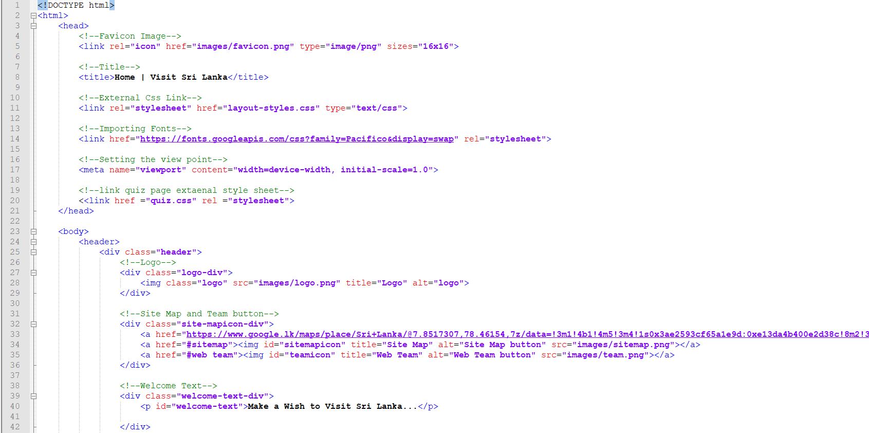

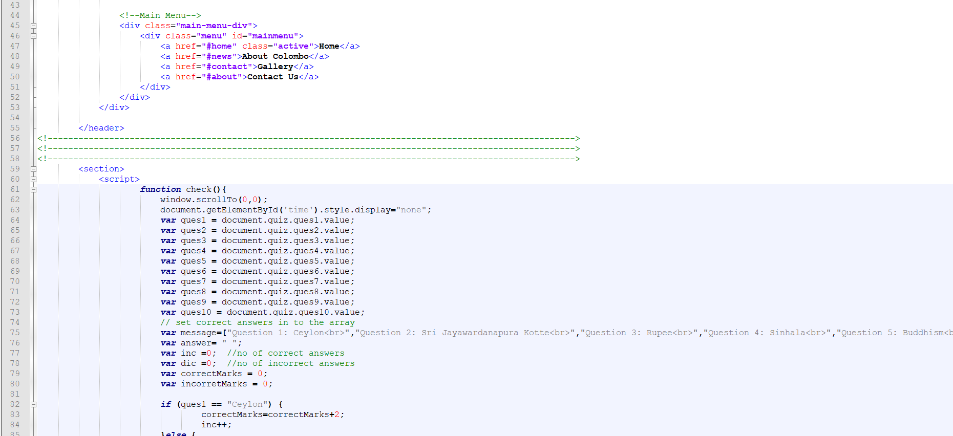

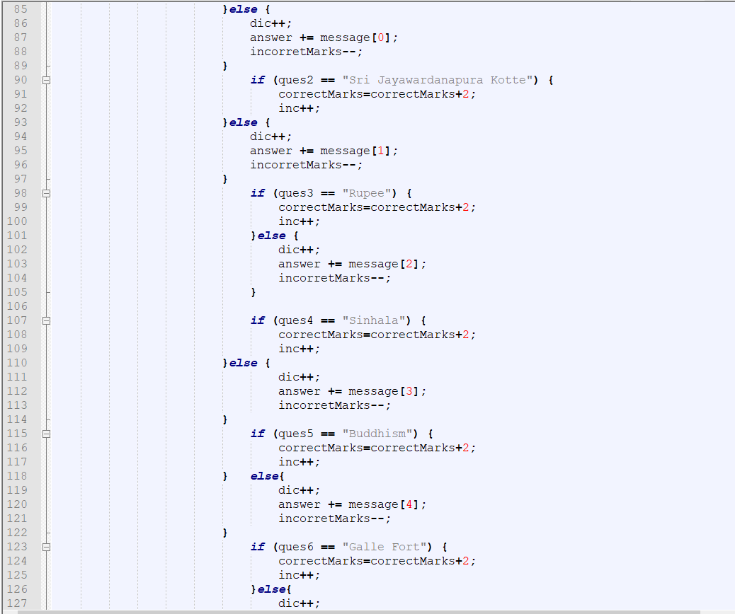

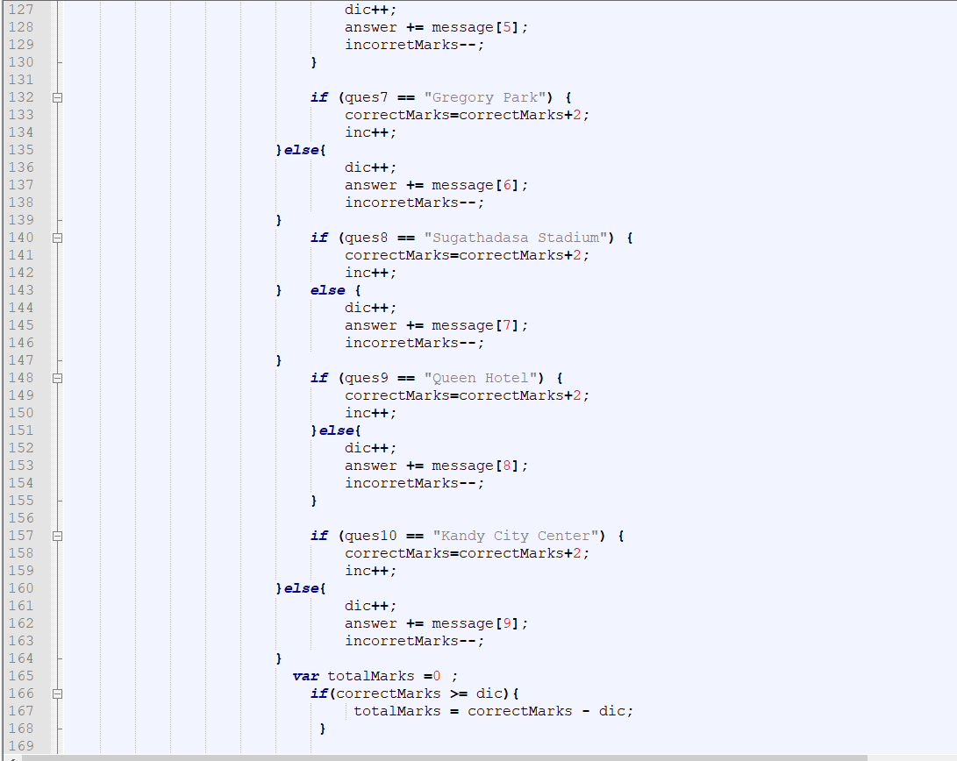

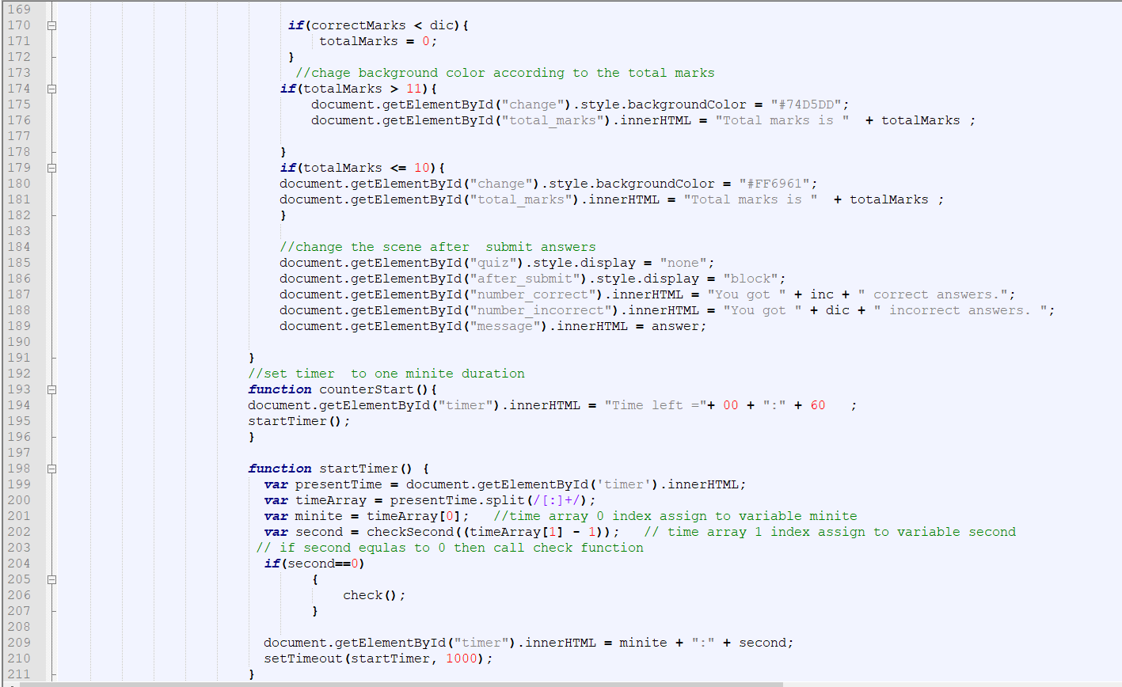

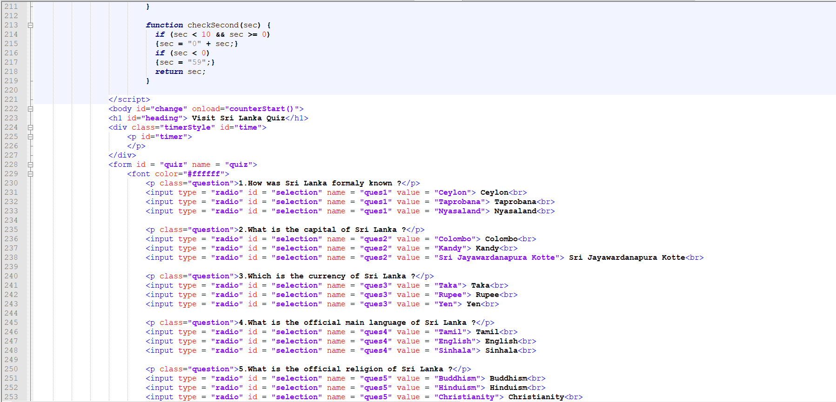

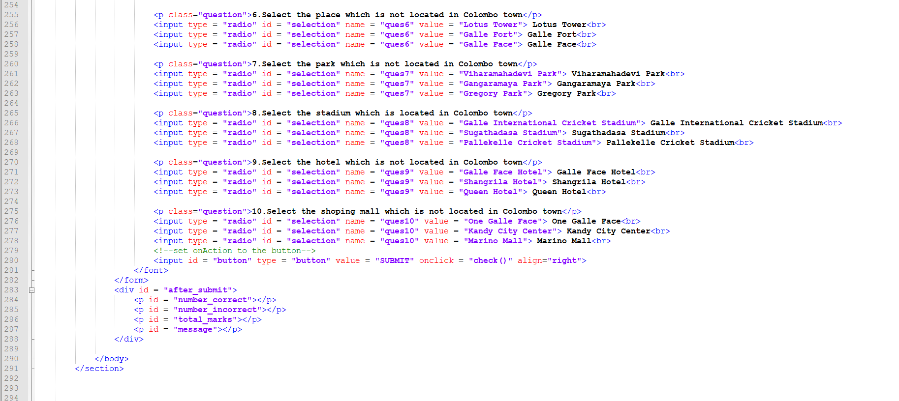

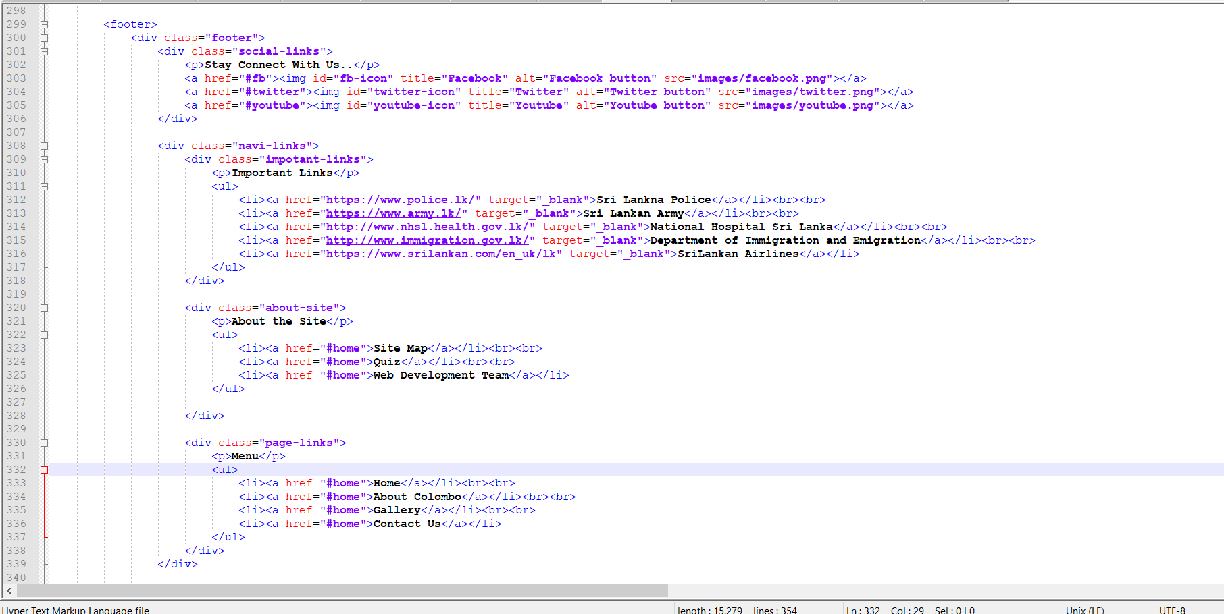

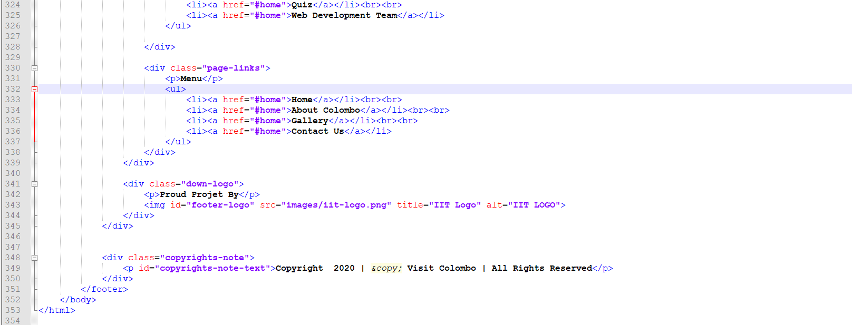

Quiz.css

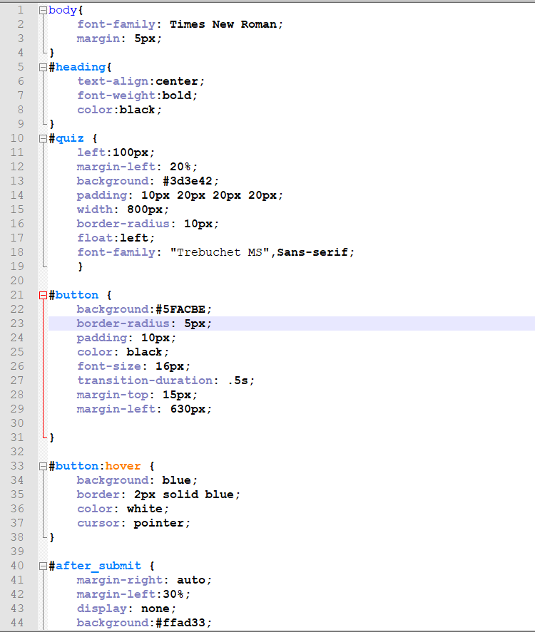

## Appendix C: Individual Statement

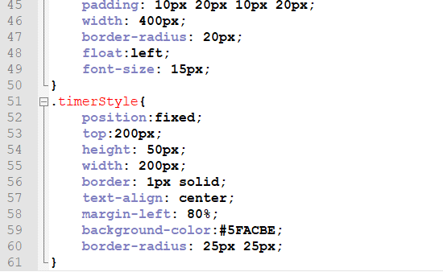

Kandy.html

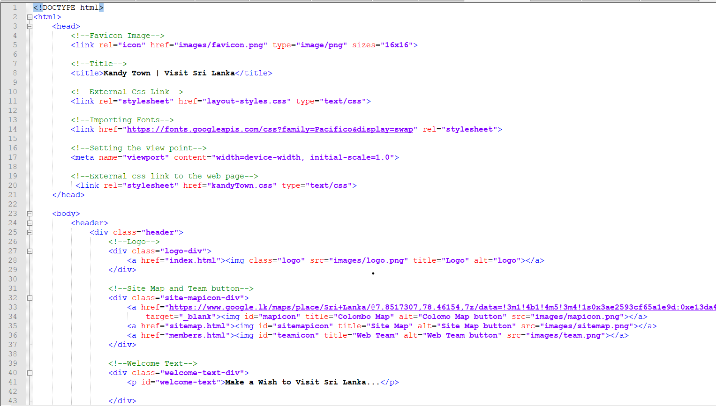

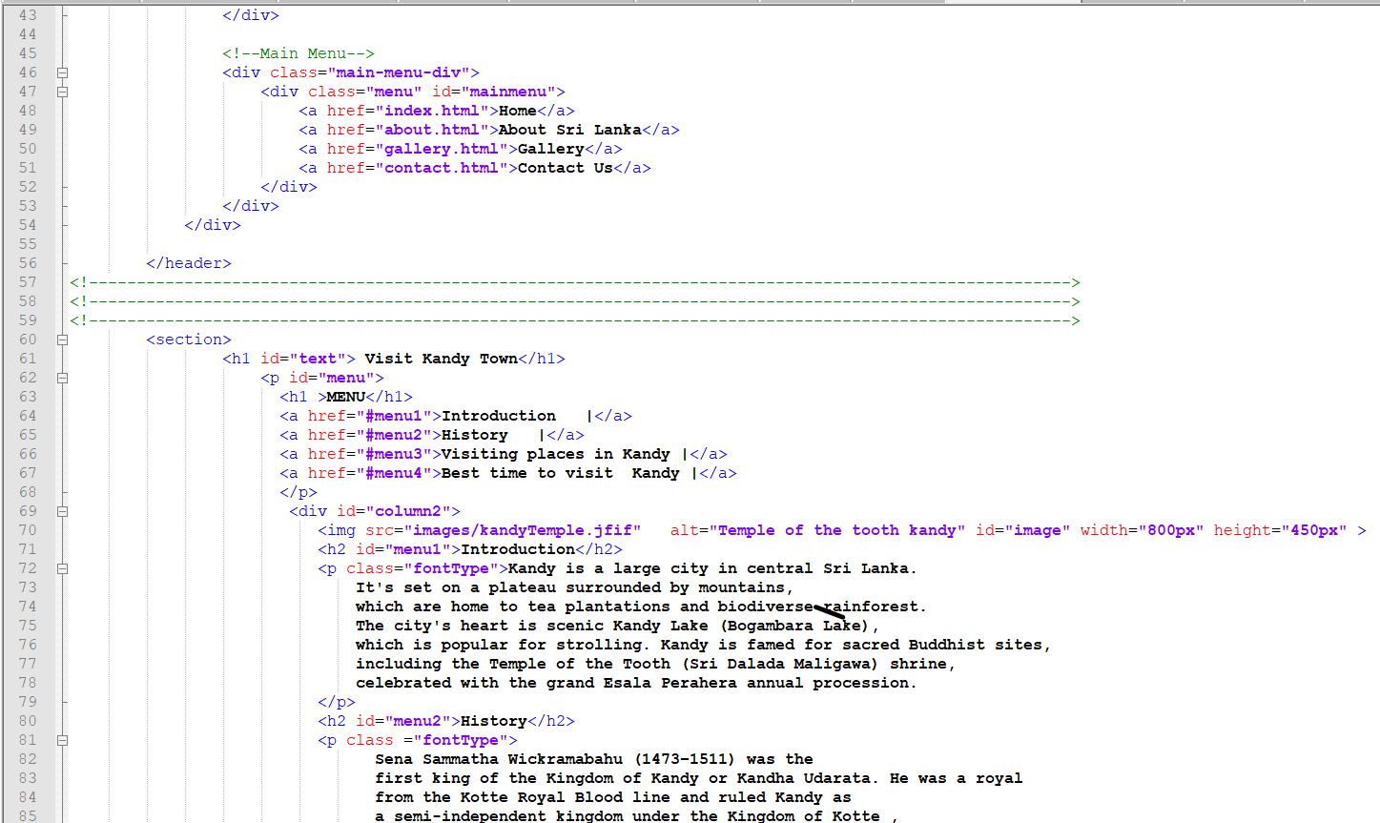

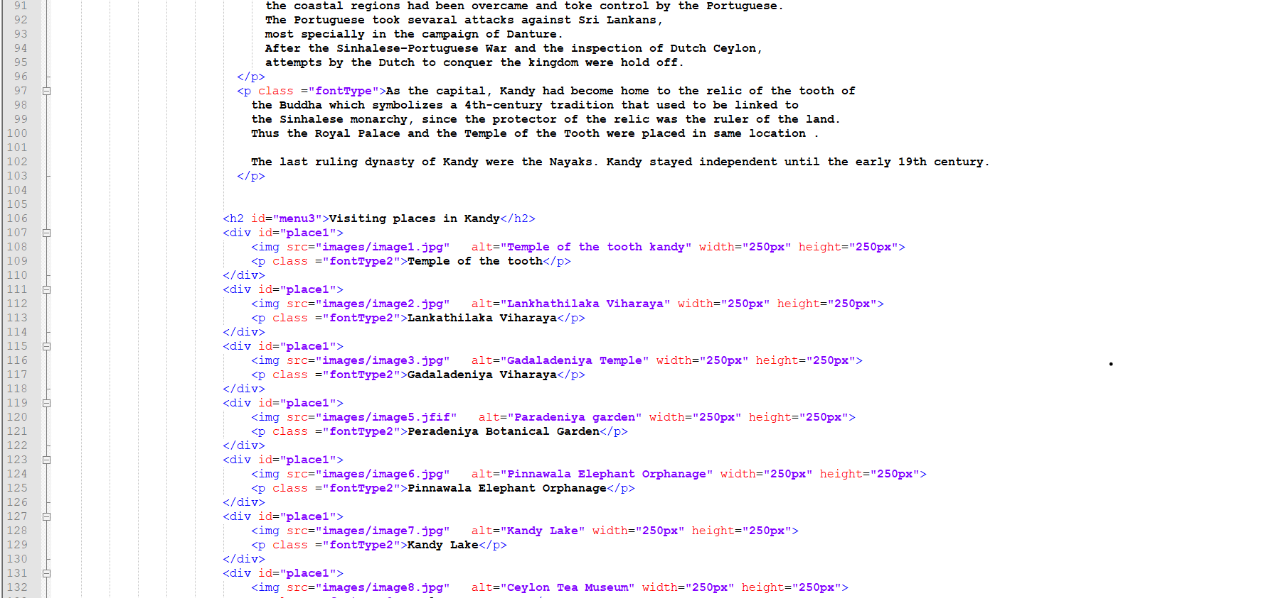

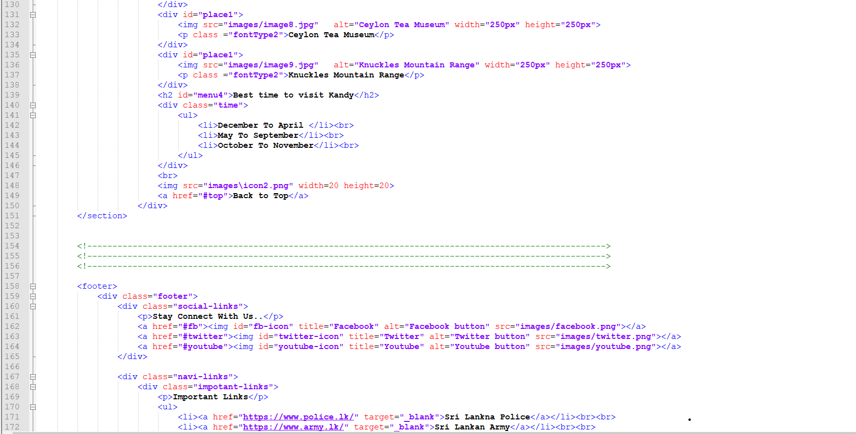

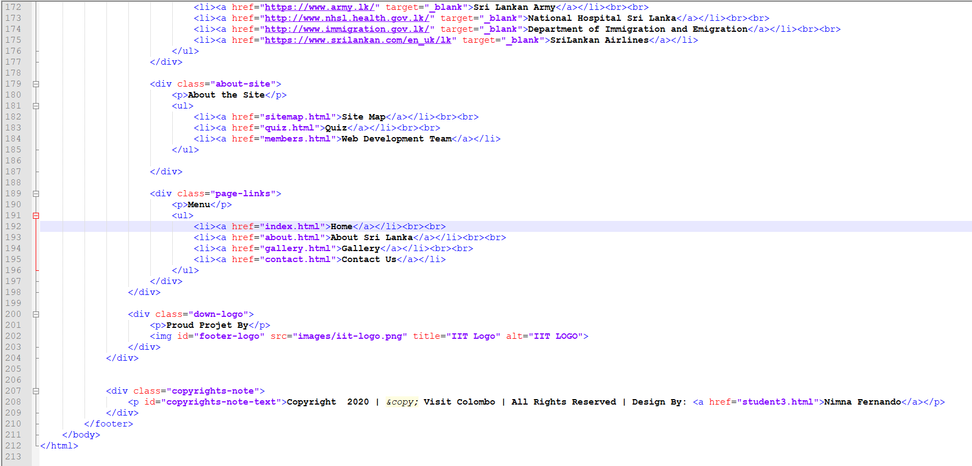

Kandytown.css

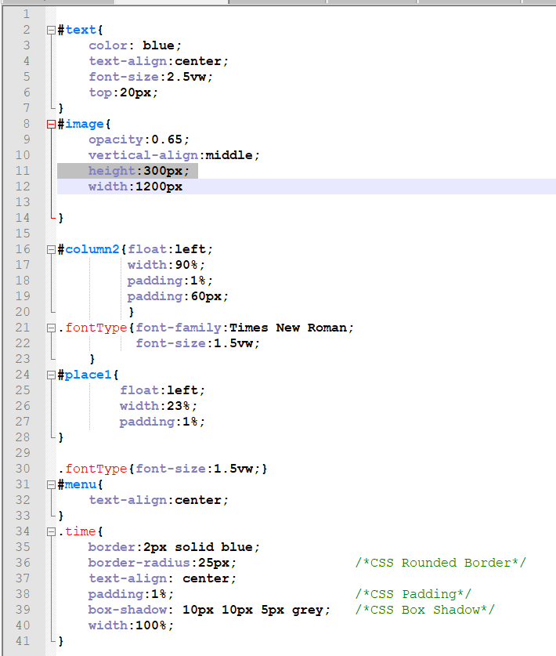

Student page

Html

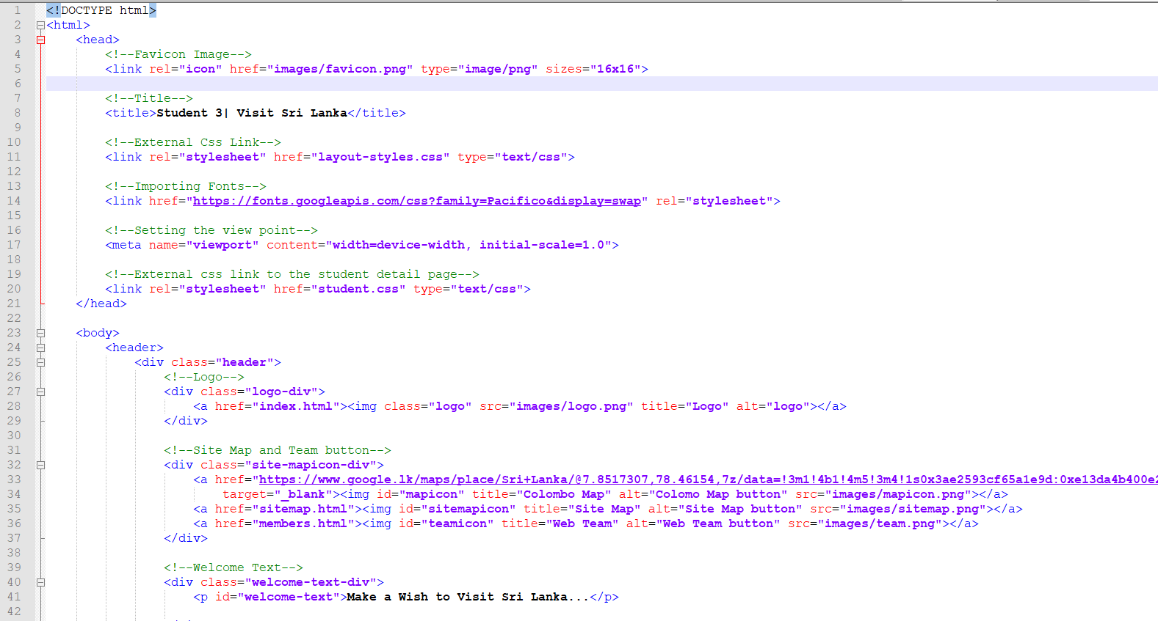

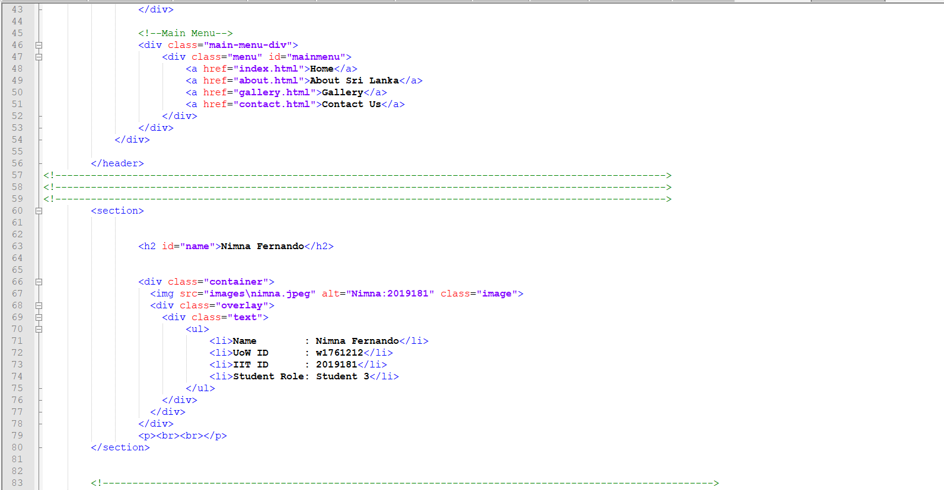

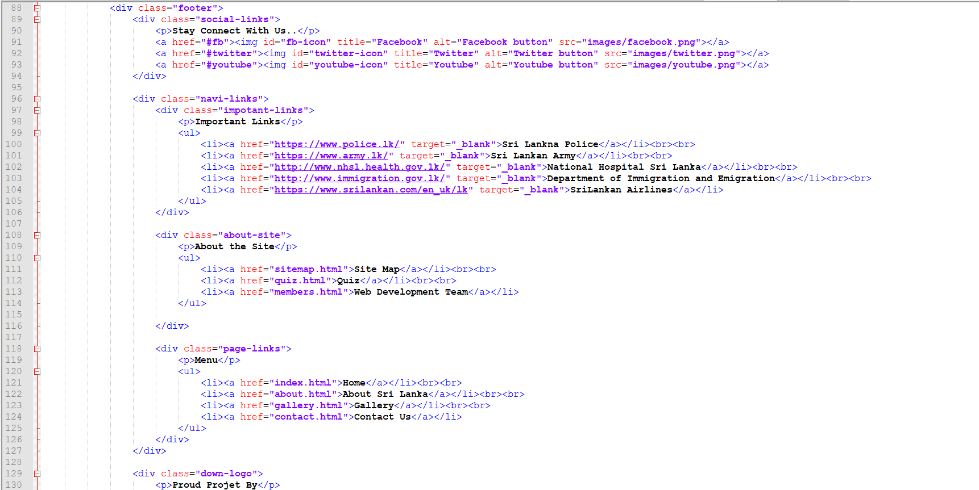

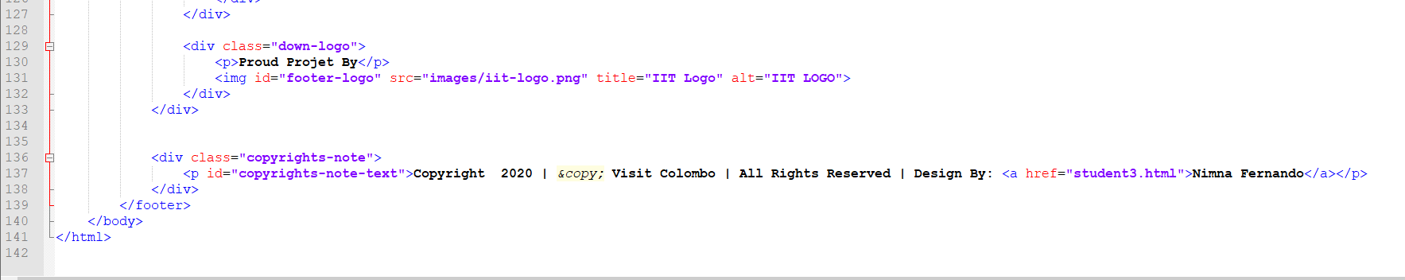

Css

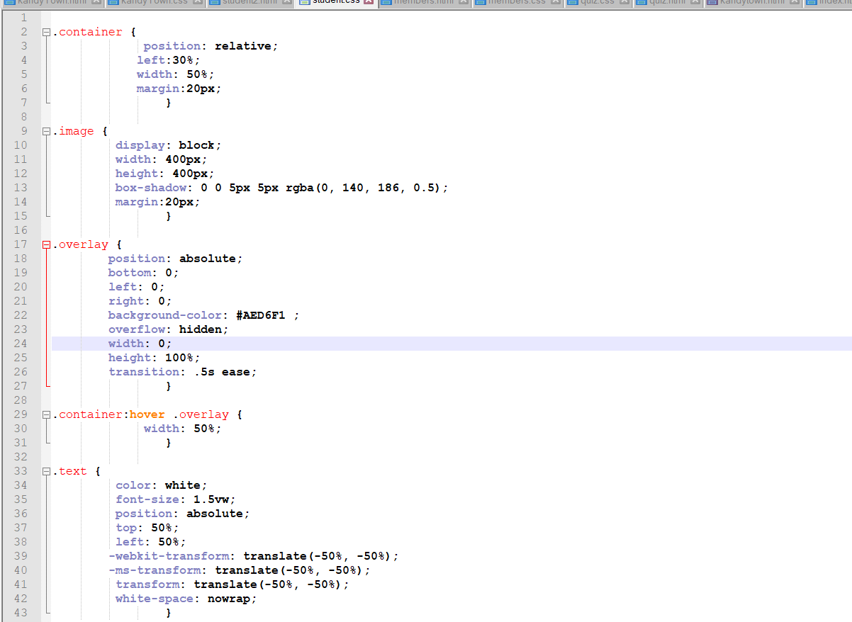



|  |  |  |  |
| --- | --- | --- | --- |
| Student Name: | Nimna Fernando | Student Id: | 2019181 |
| State what tasks you carried out in the project. | | | |
| Web quiz and group members details pages  And also I created team member page. | | | |
| State what you enjoyed and did not enjoy about teamwork. | | | |
| As a team we helped everyone to complete our project.  But at the last moment one of our team member informed us he is planning to hold the degree.  But as a other three people work together and complete the our tasks. | | | |
| State what you learnt about teamwork. | | | |
| Helped each other  Share knowledge.  Work according to the time table | | | |
| State what skills you gained/learnt from undertaking the project. | | | |
| Listen to others opinions | | | |
| State any strengths about yourself that emerged whilst undertaking the project. | | | |
| In lab sessions I completed all tutorials, so it is strengths to me to complete this project. | | | |
| State any weaknesses about yourself that emerged whilst undertaking the project. | | | |
| I am little bit late to complete task on time. | | | |
| State how you would do things better if you were to undertake the project again. | | | |
| I will complete student one requirements according to the project specification. | | | |
| Additional general or project specific comments: | | | |
|  | | | |
| Student Signature: |  | Date: | 3/24/2020 |